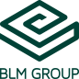

FABTECH 2023
BOOTH #A1338
For Immediate Release
BLM GROUP ANNOUNCES LT-FREE TURN TABLE 5-AXIS LASER CUTTING SYSTEM
Chicago, Ill., Sept. 11, 2023 -- In booth #A1338 at FABTECH 2023, BLM GROUP will demonstrate its new LT-FREE Turn Table 5-axis Laser Cutting System for laser cutting bent and hydroformed tubes, flat and deep-drawn sheets, and welded assemblies. This system features a rotary table with two workstations equipped with input and outputs to dynamically clamp parts in fixtures, 3D cutting head with 4kW power. The on-floor system will demonstrate processing capabilities on a bent tube, used as a heat shield for the motorsports industry.
The LT-FREE, available with fiber laser power up to 4kW, is ideal for machining mild steel, copper, aluminum, brass, stainless steel, and galvanized steel. There are no limits to part access; trimming and feature cutting can be achieved right on the bend accurately and repeatably.
Efficient and easy to operate, users just select material type and thickness from the intuitive controller, and the machine will automatically set the cutting parameters and the optimal focus position. Traditional cutting, drilling, punching, milling and deburring operations, which are normally carried out in sequence, can now be performed on a single machine. This eliminates set up and “work-in-progress” inventory, as well as reducing material handling to streamline the entire process.

Different material handling configurations are offered to meet specific production needs, while always guaranteeing the flexibility and productivity typical of this 5-axis laser cutting system.

The system is equipped with the optional user-friendly CAD/CAM software to create part programs of any complexity in a simple 3D graphical environment.

###
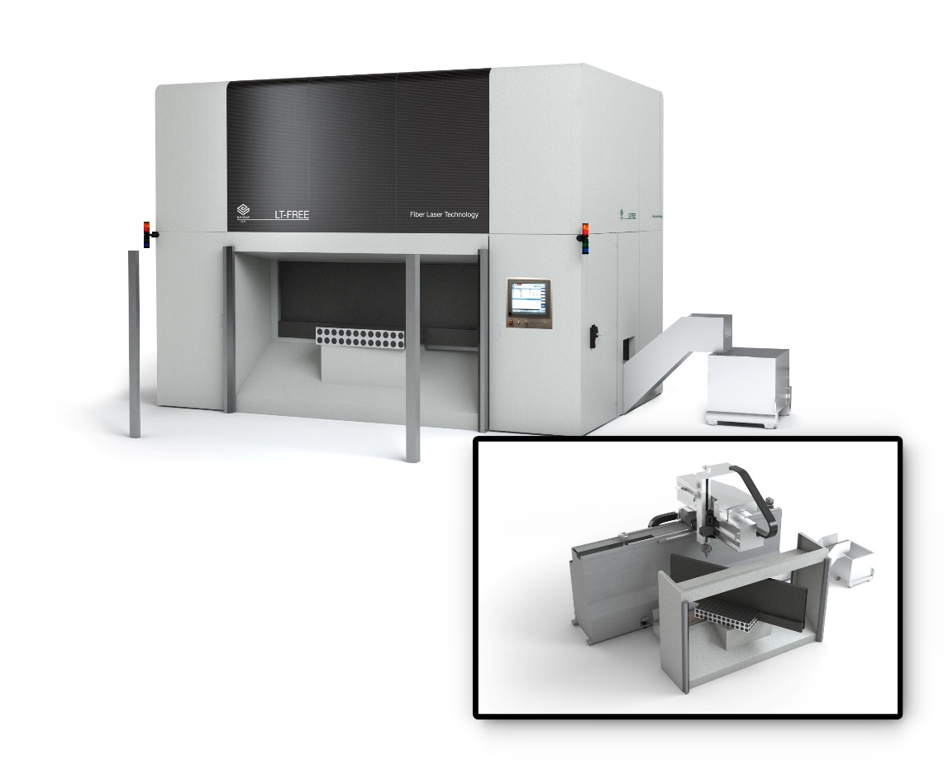
BLM GROUP will demonstrate its new LT_Free Turn Table 5-axis laser system at FABTECH 2023.

Editorial Contacts
Gunar Gossard
BLM GROUP USA
g.gossard@blmgroupusa.com
248-560-0080
Agency:
Nancy Lesinski
Industry-Scope
248-709-3040
nlesinski@industry-scope.com

