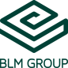

FABTECH 2023
BOOTH #A1338

For Immediate Release

BLM GROUP Fabricates Heat Exchanger Parts with Multi-Purpose 4-RUNNER Tube Forming Machine

Chicago, Ill., Sept. 11, 2023 -- In booth #A1338 at FABTECH 2023, BLM GROUP is demonstrating the capabilities of its 4-RUNNER H1 tube forming machine, highlighting its ability to de-coil/straighten, bend, end form, and cut from coil stock all in one piece of equipment. The 4-RUNNER will process two different heat exchanger-type parts suited for HVAC or refrigeration equipment, highlighting the system’s serpentine bending capabilities as well as its ability to perform multiple processes on one machine. Both tubes include multiple bend radii and endforming of one end of each tube; an expansion on Part 1 and a bead form on Part 2).

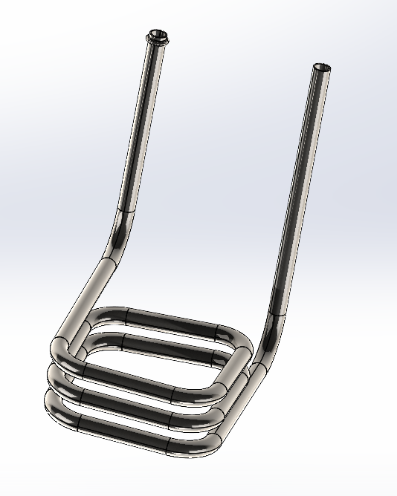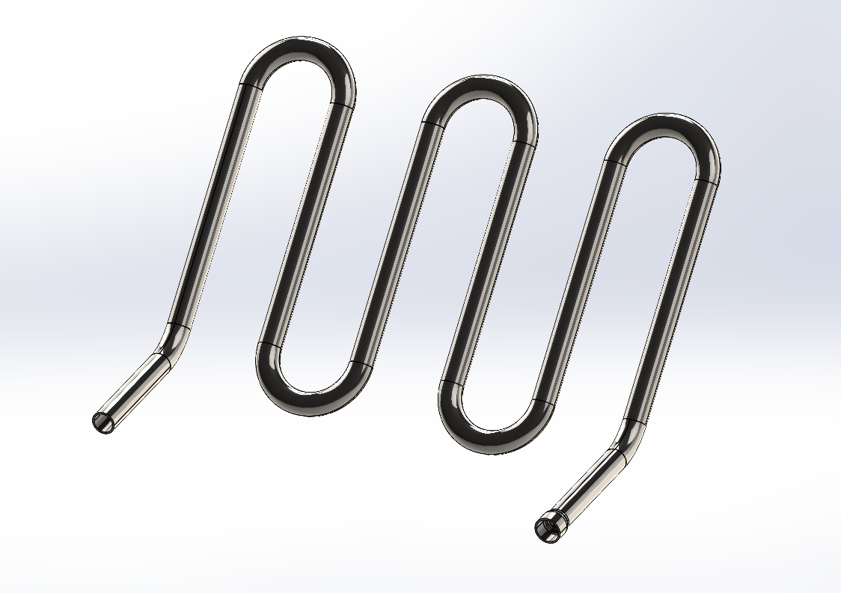
Part 1 Part 2

More on the 4-RUNNER: The 4-RUNNER H1 straightens, shapes, cuts and bends, with compression or variable radius method. It can perform multi-radius right-hand and left-hand bending operations and can work diameters up to 12.7 mm (.5”) from coil. The system is particularly suited for making flat and three-dimensional serpentines; these parts are typically used in the refrigeration, HVAC, automotive and household appliances industries.

It can be equipped with either a heavy end-forming module with six ram or four ram stations and one rotary station featuring either an external orbital or disc cutting system; or a light end-forming module with three ram or one ram and one rotary station.
All machine movements are managed by an electric axis with all part positions and power parameters saved together in the part program. No additional mechanical adjustments are required, helping the system achieve both fast setup and accurate positioning of all production phases and maximum repeatability.
###
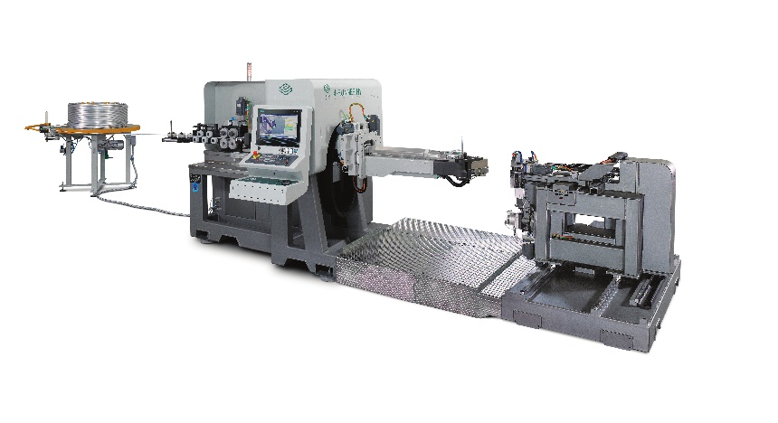
The 4-RUNNER H1 modular tube forming machine will be processing two different heat-exchanger type parts at FABTECH 2023.

About BLM GROUP
BLM GROUP is a global leader in tube and sheet metal processing solutions. Its product line includes laser tube and flat sheet cutting, cold sawing, bending, end-forming, end-machining and wire bending machines. The company has more than 60 years of experience and thousands of applications in the development of tube and sheet metal fabrication equipment. With headquarters in Italy, the North American location in Novi, Michigan, provides tube processing solutions to the United States, Canada and Mexico. For more information, please visit BLMGROUP.com, call 248.560.0080 or sales@blmgroupusa.com

Editorial Contacts
Gunar Gossard
BLM GROUP USA
g.gossard@blmgroupusa.com
248-560-0080
Agency:
Nancy Lesinski
Industry-Scope
248-709-3040
nlesinski@industry-scope.com

