FABTECH 2023
Booth #A1338

For Immediate Release

BLM GROUP Demonstrates E-TURN All-Electric Tube Bender
with Automated Load/Unload and Weld Seam and Hole Detection
Chicago, Ill., Sept. 11, 2023 -- In booth #A1338 at FABTECH 2023, BLM GROUP is demonstrating its E-TURN all-electric tube bender in conjunction with an AL5 automatic tube loader. The system will be shown processing two components –a seat frame part and a brochure stand, highlighting E-TURN’s same cycle LH and RH bending capability, as well as feature orientation using the WELDET and MC1052 weld seam and hole detection options. Both parts being processed are 304 stainless steel with a 1” OD 2” CLR x 0.065” WT (25.4mm OD x 50.8mm CLR x 1.65WT).
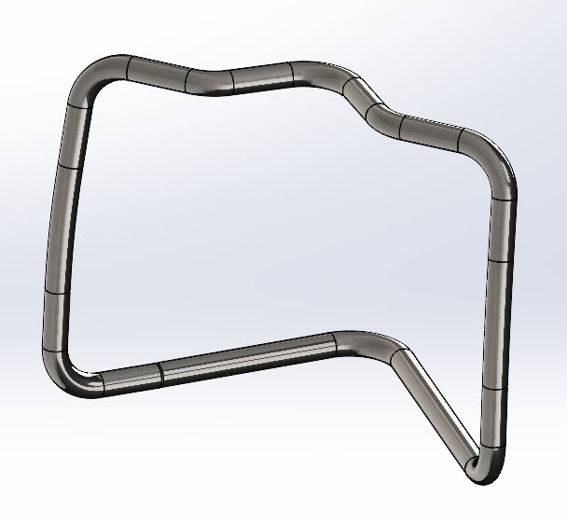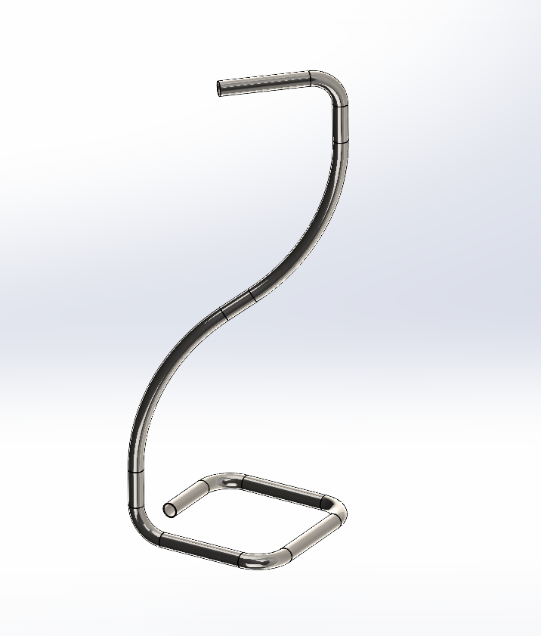
Seat Frame Part Brochure Stand Support

The E-TURN was created to meet the growing market demand for bending medium-to-small batches of complex, multiple shape tubular components of high-quality material. It is particularly well-suited for complex parts without straight stretches between bends.

E-TURN is offered in different sizes for tubes up to 52mm diameter and is used in the furniture, automotive, motorcycle, aeronautic and plant engineering sectors, but due to its flexibility and speed, can be used in all sectors.

Programming: A key differentiator of the E-TURN is the VGPNext programming and 3D simulation software. By simply inputting the component bend coordinates, the complete bending program is graphically simulated, highlighting potential collision risks and producing the optimal working cycle. Component feasibility is checked virtually, eliminating the need for prototype tooling or physical testing on the machine. Unloading of the finished component is also automatically managed by VGPNext, with the 180-degree head rotation allowing the component to be unloaded in the position required.

Changeover times are significantly reduced, and machine-setup simplified as all the critical settings for the machine tooling are managed automatically by the CNC, including clamps, pressure die, mandrel position, retraction, center line radius, etc. Additionally, the self-calibration feature enables true simultaneous axis movement with automatic adjustment of these settings.

The all-electric technology of the E-TURN offers reduced power consumption, typically offering 80% savings as compared to conventional hydraulic bending machines. Maintenance is also reduced due to simplified cabling and components.

The E-TURN is available in four sizes capable of handling maximum tube O.D. capacity ranging from 30mm x 2mm (1.18-in. x 0.079-in.) up to 50.8mm x 1.5mm (2-in. x 0.059-in.). Depending on the system, the E-TURN offers a minimum bending radius of 25 – 35mm and a maximum bending radius of 150 to 165mm.
###
The all-electric E-Turn tube bender with automated loading by BLM GROUP

About BLM GROUP
BLM GROUP is a global leader in tube and sheet metal processing solutions. Its product line includes laser tube and flat sheet cutting, cold sawing, bending, end-forming, end-machining and wire bending machines. The company has more than 60 years of experience and thousands of applications in the development of tube and sheet metal fabrication equipment. With headquarters in Italy, the North American location in Novi, Michigan, provides tube processing solutions to the United States, Canada and Mexico. For more information, please visit BLMGROUP.com, call 248.560.0080 or sales@blmgroupusa.com

Editorial Contacts
Gunar Gossard
BLM GROUP USA
g.gossard@blmgroupusa.com
248-560-0080
Agency:
Nancy Lesinski
Industry-Scope
248-709-3040
nlesinski@industry-scope.com

