FABTECH 2023
Booth #A1338

For Immediate Release

BLM GROUP Processes Exhaust Heat Shield Part with ELECT Tube Bender and LT-Free 3D Cutting Cell
Chicago, Ill., Sept. 11, 2023-- BLM GROUP will demonstrate the capabilities of its ELECT 102 tube bending machine in conjunction with its LT-Free Piece Value 5-axis laser system at FABTECH 2023 in booth #A1338, through the processing of an exhaust heat shield type part. The tubular part is made of mild steel with 3.5” OD x 5.3” CLR x 0.083” WT (88.9mm OD x 135mm CLR x 2.11mm WT). It will go through draw bending on the ELECT and then be laser cut on the LT-Free equipment.
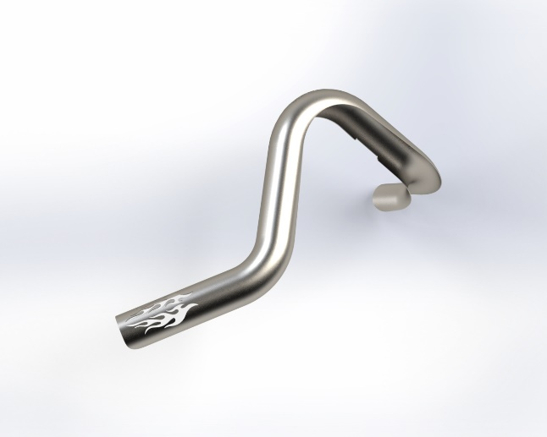
Stainless steel heat shield type part being processed at FABTECH.

ELECT Tube Benders: Available in six models, all ELECT machines are capability of processing either RH- or LH-bending, with some having the ability to quickly switch as needed. With multiple tool stack capability, the ELECT can accommodate up to eight tools, producing fixed and variable radii in a single setup.

The all-electric operation provides energy efficient production and eliminates the need for hose and piping associated with hydraulic systems. This helps simplify maintenance and improve reliability for more consistent bending. These 9-axis systems are well-suited for tube production in a variety of industries including HVAC, furniture, automotive and aerospace.

The BLM GROUP ELECT tube benders can incorporate automatic tube bundle loading and a handling robot for a complete turnkey solution that manages the entire tube loading and unloading sequence. For more information on the ELECT benders, visit https://www.blmgroup.com/3d-cutting-cells/lt-free

LT-FREE Piece Value: The LT-FREE Piece Value 5-axis Laser Cutting System features a large rotary indexing table that offers efficient and continuous production of large batch processing of any 3D part. With laser powers up to 3kW and rotary table dimensions of 3000mm diameter, the LT-FREE is ideal for machining a variety of materials.
Traditional cutting, drilling, punching, milling and deburring operations, which are normally carried out in sequence, can now be performed on a single machine. This eliminates set up and “work-in-progress” inventory, as well as reducing material handling to streamline the entire process.
For more information on the LT-Free, visit https://www.blmgroup.com/3d-cutting-cells/lt-free

# # #

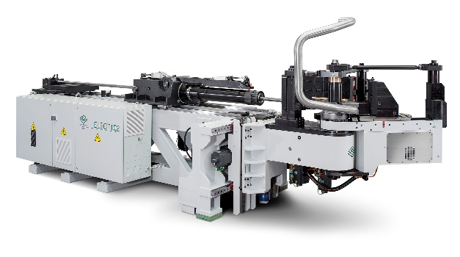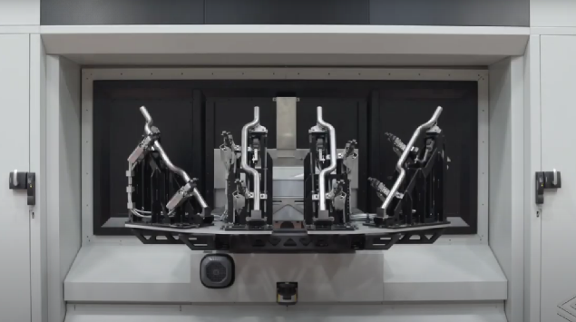
BLM GROUP will fabricate an exhaust heat shield part at FABTECH 2023 with its ELECT 102 tube bender and LT-Free Piece Value 3D laser cutting cell.

About BLM GROUP
BLM GROUP is a global leader in tube and sheet metal processing solutions. Its product line includes laser tube and flat sheet cutting, cold sawing, bending, end-forming, end-machining and wire bending machines. The company has more than 60 years of experience and thousands of applications in the development of tube and sheet metal fabrication equipment. With headquarters in Italy, the North American location in Novi, Michigan, provides tube processing solutions to the United States, Canada and Mexico. For more information, please visit BLMGROUP.com, call 248.560.0080 or sales@blmgroupusa.com

Editorial Contacts
Gunar Gossard
BLM GROUP USA
g.gossard@blmgroupusa.com
248-560-0080
Agency:
Nancy Lesinski
Industry-Scope
248-709-3040
nlesinski@industry-scope.com

