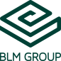

FABTECH 2023
A1338

For Immediate Release

BLM GROUP Demonstrates Flexibility of LS7 Laser Cutter Featuring Nozzle Change
and New Automated Load/Unload
Chicago, Ill., Sept. 11, 2023 -- At FABTECH 2023 in booth #A1338, BLM GROUP will demonstrate the speed and versatility of its newest sheet laser machine – the LS7, which will be equipped with a 12kW laser source and an automated load/unload system and automated nozzle change. It will be running a variety of demonstrations on materials that include mild steel, stainless steel, aluminum, copper and brass. Additionally, the system will switch between nitrogen and high-pressure compressed air as its assist gas.
As shown at FABTECH, the automated load/unload system includes a single fork with anti-scratch belts, is expandable to include a single tower and has an open design that allows for manual loading on the backside.

The LS7, offering an axis acceleration of up to 2g, will demonstrate its fly-cut ability to laser cut grids, which can decrease cutting time by 70%. Additional speed can be gained through the LS7’s fully-electric pallet change, which takes a only a few seconds to extract the laser-cut parts and load the new sheet metal. Also demonstrated will be the machine’s Active Piercing ability, which increases piercing speed and reliability, even on inconsistent material quality and thickness.

The LS7 can cut thicknesses from 0.20” to 1.57”, or even double sheets, depending upon the material and selected laser power. It is available in two versions – the 3015 with a maximum sheet size of 121.5” x 62.2” and the 4020, capable of handling sheet sizes up to 162.5" x 79.5".
Importantly, the system is built in a way that enables extremely quick installation. More information on the LS7 is available at LS7 Sheet Lasers.

# # #
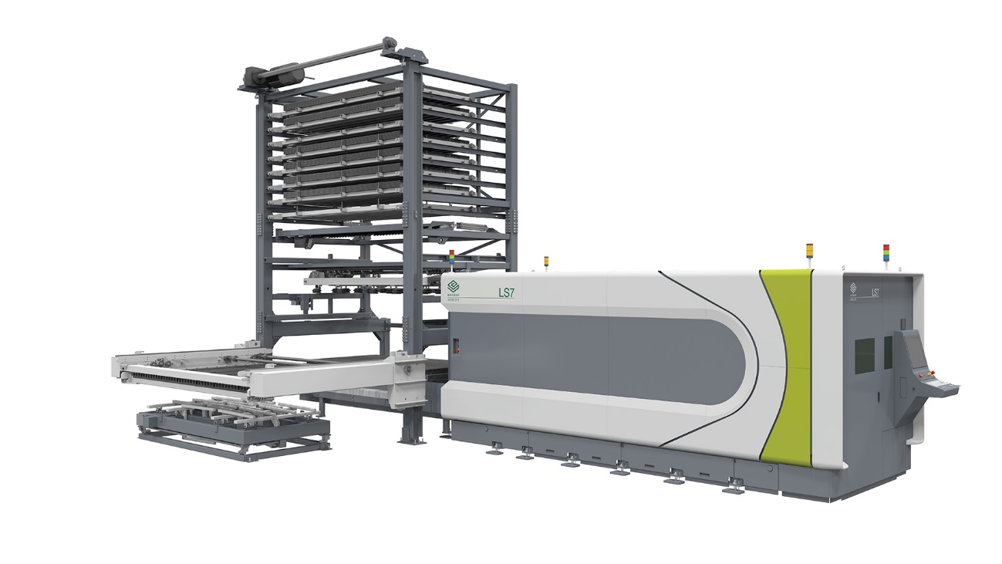

BLM GROUP will demonstrate its LS7 laser cutter coupled with automated load and unload at FABTECH 2023.

About BLM GROUP
BLM GROUP is a global leader in tube and sheet metal processing solutions. Its product line includes laser tube and flat sheet cutting, cold sawing, bending, end-forming, end-machining and wire bending machines. The company has more than 60 years of experience and thousands of applications in the development of tube and sheet metal fabrication equipment. With headquarters in Italy, the North American location in Novi, Michigan, provides tube processing solutions to the United States, Canada and Mexico. For more information, please visit BLMGROUP.com, call 248.560.0080 or sales@blmgroupusa.com

Editorial Contacts
Gunar Gossard
BLM GROUP USA
g.gossard@blmgroupusa.com
248-560-0080

Agency:
Nancy Lesinski
Industry-Scope
248-709-3040
nlesinski@industry-scope.com

