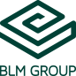
FABTECH 2023
A1338

For Immediate Release

BLM GROUP Processes a Variety of Components to Illustrate LT7 Tube Laser Versatility
Demonstrations include Drill and Tap, Active Tools, Automated Load/Unload, Compressed Air Capabilities

Chicago, Ill., Sept. 11, 2023 — In booth #A1338 at FABTECH 2023, BLM GROUP will be processing a variety of parts to demonstrate the versatility of its LT7 lasertube featuring 5kW laser power with automated load/unload and a thread insert unit, which automatically installs thread inserts into laser cut holes by press fitting. A patent-pending technology exclusive to BLM GROUP, this inserter unit simplifies and shortens the processing time for mating an insert with a tubular component.

Materials being processed include 1” square stainless steel with 0.049” WT (wall thickness), a 4” round aluminum section with 0.25” WT, a 4”x2” special section of aluminum with 0.125” WT, a 2.5”x2.0” mild steel angled section with 0.375” WT, and a 3” square section of mild steel with 0.083” WT. Various features being processed include tooth and slot joint, T-hook and slot, semi-chamfer hole, cut-bend, rivet insertion and more.

Capable of using a variety of assist gases, the LT7 will process the aluminum sections using high pressure dry compressed air. The machine is equipped with Active Tools including Active Scan (with extension for special shapes), Active Weld, and Active Tilt, all designed so that the LT7 can automatically adapt process parameters for optimal results.

The LT7 features a 3D tilt cutting head and can perform high-precision angular cuts in round tubes, square, rectangle, and open profiles, and special sections. It can process round/square/open profile/custom sections from 0.5” to 6”, up to 15.5 lbs./ft., and is available with a 3, 4 or 5kW fiber laser.

Programming
BLM Group’s proprietary software ArTube makes for easy/automatic offline programming. Jobs can be setup offline allowing the operator to simply activate their job, load material, and unload finished parts.

###
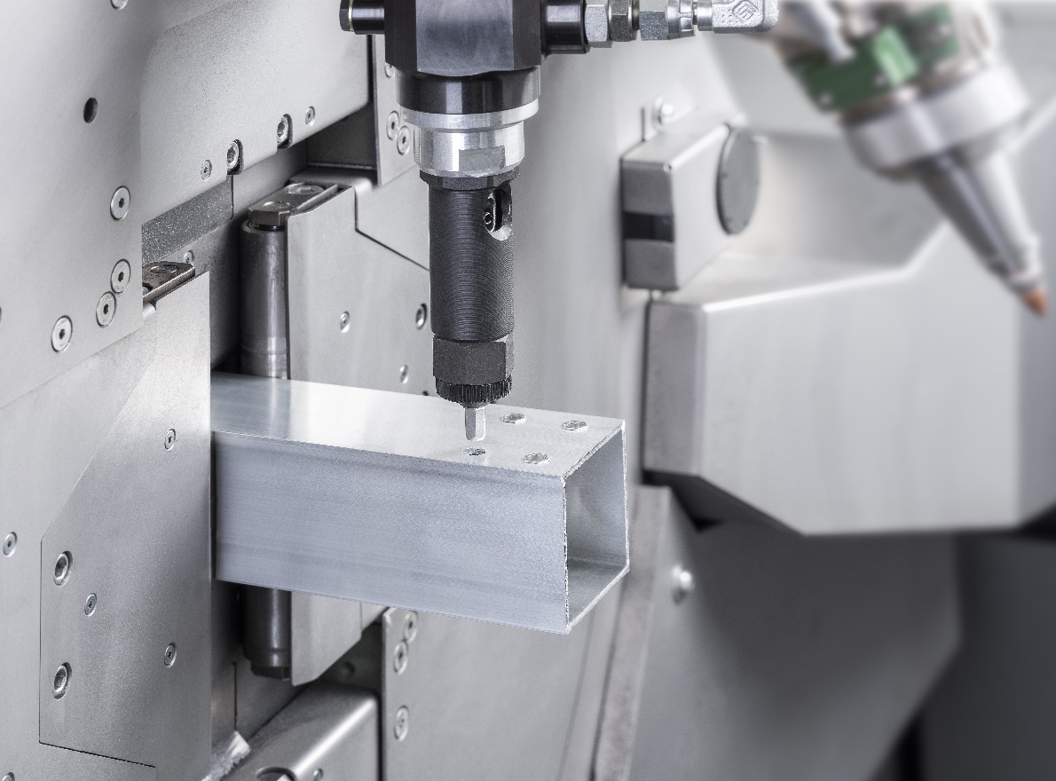
BLM GROUP is demonstrating the versatility of its LT7, including its patent-pending Inserter unit, at FABTECH 2023

About BLM GROUP
BLM GROUP is a global leader in tube and sheet metal processing solutions. Its product line includes laser tube and flat sheet cutting, cold sawing, bending, end-forming, end-machining and wire bending machines. The company has more than 60 years of experience and thousands of applications in the development of tube and sheet metal fabrication equipment. With headquarters in Italy, the North American location in Novi, Michigan, provides tube processing solutions to the United States, Canada and Mexico. For more information, please visit BLMGROUP.com, call 248.560.0080 or sales@blmgroupusa.com

Editorial Contacts
Gunar Gossard
BLM GROUP USA
g.gossard@blmgroupusa.com
248-560-0080
Agency:
Nancy Lesinski
Industry-Scope
248-709-3040
nlesinski@industry-scope.com

