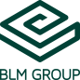
FABTECH 2023
Booth #A1338

For Immediate Release
BLM GROUP Announces New Automated ProBend Press Brake Cell at FABTECH 2023
Chicago, Ill., Sept. 11, 2023 – BLM GROUP has announced its new automated ProBend press brake cell, which is being demonstrated at FABTECH 2023 in booth #A1338. This compact workcell, with an overall size of (LWH) 281” x 162’ x 122”, features the ProBend E-Series 205-60 and a 30kg robot. It has the flexibility to process a wide variety of part sizes from 4” x 3” up to 24” x 32” and 33 lbs. with excellent reliability and high productivity. The E-Series 205-60 press brake has a bending force of 66 tons, a bending length of 81”.
The system has two load and unload locations with the ability to integrate the unload pallets with an AGV as desired. The pre-load section is configurable for adaptation to part geometry, as well as allowing its removal to accommodate larger parts. The 3-axis Cartesian pick and place system with pivoting head allows the robot to continue processing parts while staging the next piece of material.

The automatic tool change capability requires minimal operator intervention, making tool change between parts very fast and easy. With up to six meters of tooling storage, there is ample space for tooling needs. Plus, the system can handle a variety of end-of-arm-tooling types – vacuum, magnet and gripper-style, for processing various types of materials.

The ProBend E-Series press brakes feature a patented, direct-drive system with twin torque motors and an open “C” frame design, providing the ability to form off the edge of the machine. As compared to industry standards, the E-Series, with a ram tilt up to 3/8”, offers a generous open height, stroke and throat size, benefiting deep box or special forming needs. Built for optimum accuracy and high speeds on all 6-axes, the E-Series’ CNC-controlled backgauge meets the demands of the most complex sheet metal applications for high-production manufacturing.
Offline software package gives you complete control to go from part drawing to pallet in minutes.
For more information on the new ProBend press brakes, visit https://www.blmgroup.com/en-us/press-brake/probend
###
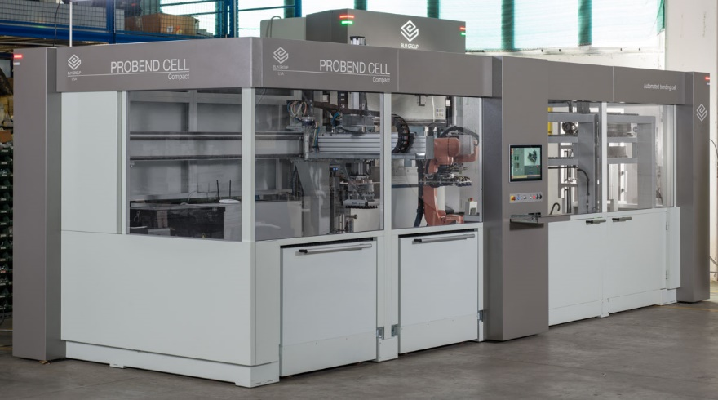
BLM GROUP’s new ProBend Automated Robotic Press Brake Cell

BLM GROUP is a global leader in tube and sheet metal processing solutions. Its product line includes laser tube and flat sheet cutting and bending, cold sawing, end-forming, end-machining and wire bending machines. The company has more than 60 years of experience and thousands of applications in the development of tube and sheet metal fabrication equipment. With headquarters in Italy, the North American location in Novi, Michigan, provides tube processing solutions to the United States, Canada and Mexico. For more information, please visit BLMGROUP.com, call 248.560.0080 or email sales@blmgroupusa.com

Editorial Contacts
Gunar Gossard
BLM GROUP USA
g.gossard@blmgroupusa.com
248-560-0080
Agency:
Nancy Lesinski
Industry-Scope
248-709-3040
nlesinski@industry-scope.com

