FABTECH 2023
BOOTH #A1338

For Immediate Release
BLM GROUP Demonstrates VGPNext Newest Generation Bending Software
Chicago, Ill., Sept. 11, 2023 -- In booth #A1338 at FABTECH 2023, BLM GROUP is demonstrating the VGPNext, the new CAD/CAM programming software for its tube bending and wire bending machines that tackles the latest technological challenges. The software features a completely revolutionized graphical user interface, with a wealth of features just a click away, designed to make the operator's job easier and machine programming more practical and simpler. VGPNext, which is part of the BLMelements software suite, improves the synergy between machine and software by simplifying core functions for more user-friendly programming. With VGPNext you can identify the part program right away, simulate the job and start production in just a few clicks.

More methods for programming the part
VGPNext allows you to choose a program from the library using an archive containing images and technical data. The library collects all the programs on the server in one place, providing the convenience of preview images and numerous search filters to make this step even easier. Customized tags can be assigned to the various part programs and searches can be filtered by tag, section, material, date, machine and much more.
Importing a part program
The B_import module can be used to call up a tube or multi-tube assembly in STEP or IGES formats in VGPNext to automatically obtain theoretical coordinates. This saves a lot of time and allows less experienced operators to quickly become familiar with the program.
Modelling from scratch
The entire programming flow is more user-friendly with the help of a ribbon bar that assists the operator by indicating missing steps, incorrectly filled-in data, default data and user-modified data.
In this way, VGPNext considers all possible variables – including theoretical coordinates, springback, material elongation, bending feasibility, choice of tools, etc. – and indicates how to intervene. The operator can switch from one step to the next without losing valuable data. The 3D simulator incorporated in VGPNext can be used to simulate feasibility once the part has been programmed and the geometric deformations are corrected.
3D simulation and time estimation
VGPNext is equipped with a realistic simulator that anticipates potential collisions between the machined part and the machine to avoid contact and ensure safe production. Each machine is identified by its serial number, so the software knows the exact configuration of the machine and the respective accessories. This allows VGPNext to recognize two machines of the same family with different configurations. The simulations reflect the exact conditions of the machine and can provide even more accurate cycle time data.
Targeted defect correction
A defect-correction catalogue is available in VGPNext, allowing the operator to conveniently select the most suitable correction without having to redesign the entire part program. The machine will then suggest which correction to make and set the parameters for the correction.
Monitoring
This function provides a complete overview of the machine’s efficiency over the entire day. It allows you to monitor the daily production of your system including checking the cycle time of the workpiece, the various completed jobs and the total number of rejects among other factors.
Plug-ins
The plug-in screen manages additional functions to simulate changes in the productivity of the system with and without a given function so that you can evaluate whether to purchase it in the future.

For more information: https://youtu.be/u1aTvxqlgYI
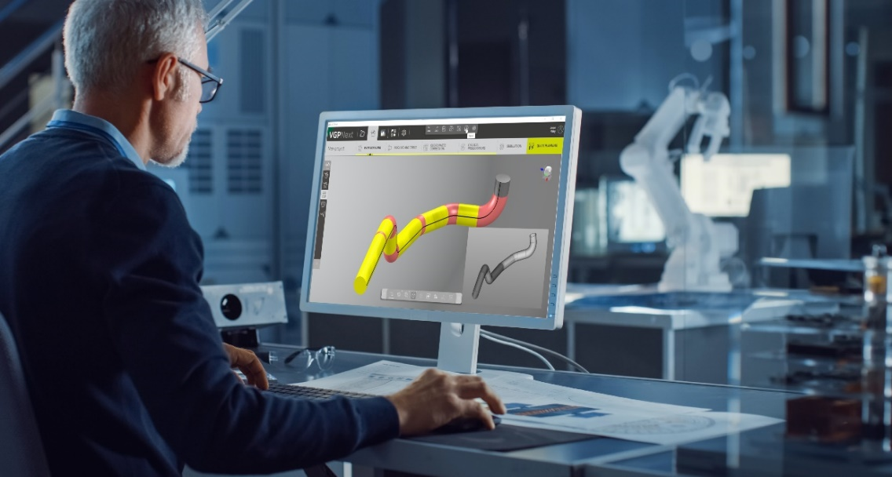
BLM GROUP will demonstrate its newest CAD/CAM bending software VGPNext at FABTECH 2023.

Editorial Contacts:
Gunar Gossard
BLM GROUP USA
g.gossard@blmgroupusa.com
248-560-0080
AGENCY
Nancy Lesinski
248-709-3040
nlesinski@industry-scope.com

