- Brankamp Monitoring: Food Industry Applications
Cans, Bottles, Lids (Pull-Tab), Closures, Bins, Casks
Machines: Shell Presses, Drawing Presses, EOE: Minster
- Today, over 400 billion cans are manufactured in the world each year for use in the food Industry. However, it has never been possible to guarantee 100% consistent quality of the metal packaging. Many different testing procedures have proven to be too expensive and not very practicable, in economic terms. Recently there has been a move away from these post-process control techniques and towards in–process monitoring directly in the machine. This provides the possibility of immediately identifying manufacturing faults and selecting out faulty parts.
Quality problems in the manufacture of pull-off lids can arise in different stages of shaping. In the first shaping stage, the bubble is drawn out of the pre-pressed shell. During this work process, there can be sporadic material failures, eg., the sheet metal tears, thus the requisite shaping force reduces. The bubble is then shaped in a number of steps to form a cylindrical button. Tears can also occur during these steps. Issues are often the result of residual compounds on the tool, or chips from the clip tool.

In the channeling stage, the channel depth is checked to determine the force required to open the lid. In the riveting stage, the clip is riveted to the lid. In this stage, sporadic misalignment of lid and clip can occur, impacting problem-free opening of the lid.
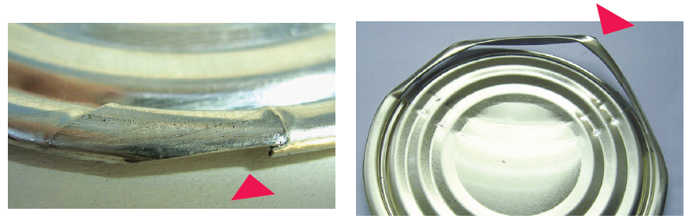
Clip-out Clip-out Failure

The solution
Using force sensors in the individual tool stages, the shaping forces are measured in real-time. Faults are recognized immediately, with the result that rejecting good parts are a thing of the past. This means that in-process quality control is considerably more advantageous, in economic terms, than downstream checking procedures

