E-Mobility Specialists

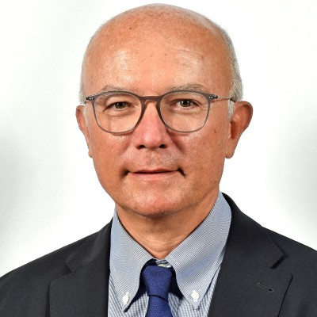

Gabriele Celli, International Account Manager
A 36-year employee of Marposs, Gabriele coordinates global key account activities and development of the North America electric vehicle market.

Scott Lukomski, EV Business Director
With a career focused on quality in manufacturing, Scott is responsible for expanding Marposs’ business within the electric vehicle sector, including battery testing, electric motor testing, machine monitoring and other solutions.

Alberto Tomirotti, Product Manager
Alberto has worked with Marposs for 17 years, helping to focus on new markets and focusing on the e.d.c. product line, which provides functional test solutions for electric motors based upon partial discharge measurement.

Daniel Seikaly, Product Manager, Assembly and Leak Test Systems
Dan is a 38-year veteran of Marposs test and inspection systems, currently serving as product manager for non-destructive leak and flow test systems, which include the Tecna and HeTech brands.

Silvio Dalbuono, Product Manager, MeSys
MeSys develops and manufactures on-line measurement and control systems for production of film, sheet, foils, coating and laminating products. MeSys GmbH was acquired by Marposs in early 2023.

Yutaro Okada, Project Manager, Battery Testing
Working within the Elettrosystem group of Marposs, Yutaro oversees the development of automated systems for assembly and testing, with high competence in electromechanical and robotics.







