For Immediate Release

BATTERY SHOW 2023
Booth #1016

Marposs Test Systems Provide Quality Testing of Electric Motor Components
Unique Technology Offers Ability to Perform Multiple Tests with One System

Novi, Mich., Sept. 12, 2023 – Marposs, a global leader in measurement, inspection and test technologies, offers electrical testing systems, integrating e.d.c. partial discharge measurement technology, to ensure the integrity of windings, coils and stators of electric motors. The LT400 system is designed for use in a lab or quality department while the AST320/W expands these capabilities with a system designed for production environments. With these systems, companies can perform standard high voltages tests (AC and Pulse) with Partial Discharge measurements that identify defects that would not be revealed with standard tests.
The e.d.c. partial discharge technology utilized in these systems is based upon partial discharge measurement using capacitor coupling. In comparison to the more traditional methodology of radio frequency antennas, capacitor coupling is less sensitive to external noise while maintaining the same measurement quality, ultimately leading to a more cost and space effective solution in production environments.
The capacitor coupling approach eliminates the need for an external sensor. Using the same cables, the partial discharge measurement test can be performed simultaneously with the standard AC High Pot and Surge tests, offering a more extensive verification of the components without requiring additional testing time.
Multiple Tests from a Single System
Another main benefit of these systems is their ability to integrate numerous tests into one solution optimizing the cycle time while remaining flexible to the inspection needs. The configurable HMI, common to all the e.d.c. testing solutions, allows the user to create testing recipes that mix a variety of typical tests like winding resistance, insulation resistance, AC High Pot Tests, and Surge Tests, as well as interacting with the external world by exchanging commands and results with the available digital I/O or OPC UA interfaces.
All measurements, parameters, and testing programs are stored within the software, as are various preventive maintenance and calibration routines. Plus, users have the option to upload data and software to a local area network (LAN) and, if so equipped, request remote assistance. The printing of test and calibration certificates in multiple languages is supported for both laboratory and production system, as well is the possibility of integration with 3rd party ERP and MES systems inn production.
Correlating the laboratory results with those from the production line becomes a simpler task as the LT400 and the AST320/W share the same software and technology.

For more information on Marposs e.d.c. solutions, visit https://www.marposs.com/eng/blog/electrical-and-functional-testing-systems-for-electric-motors-and-components.

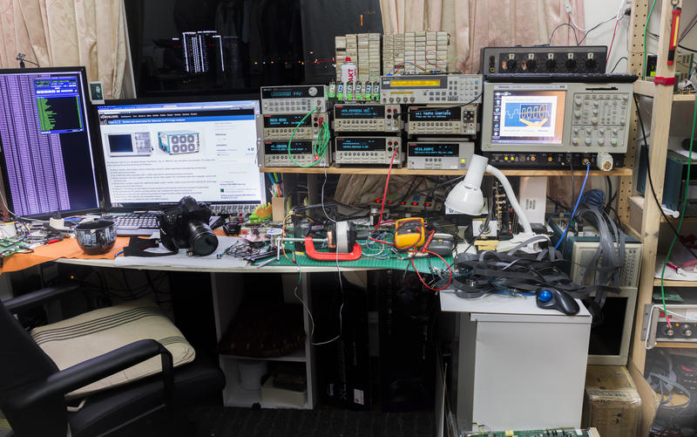 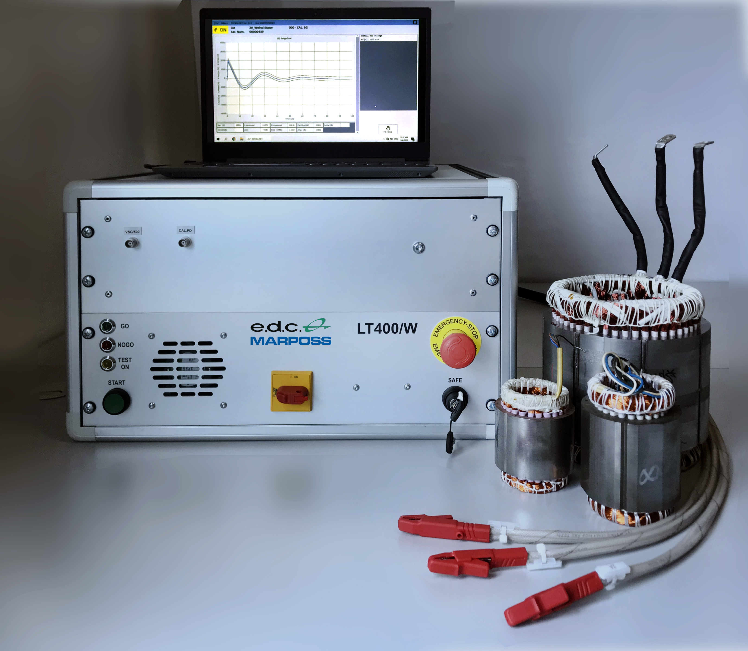
The traditional lab electrical test bench (on the left) versus the LT400 compact test system.
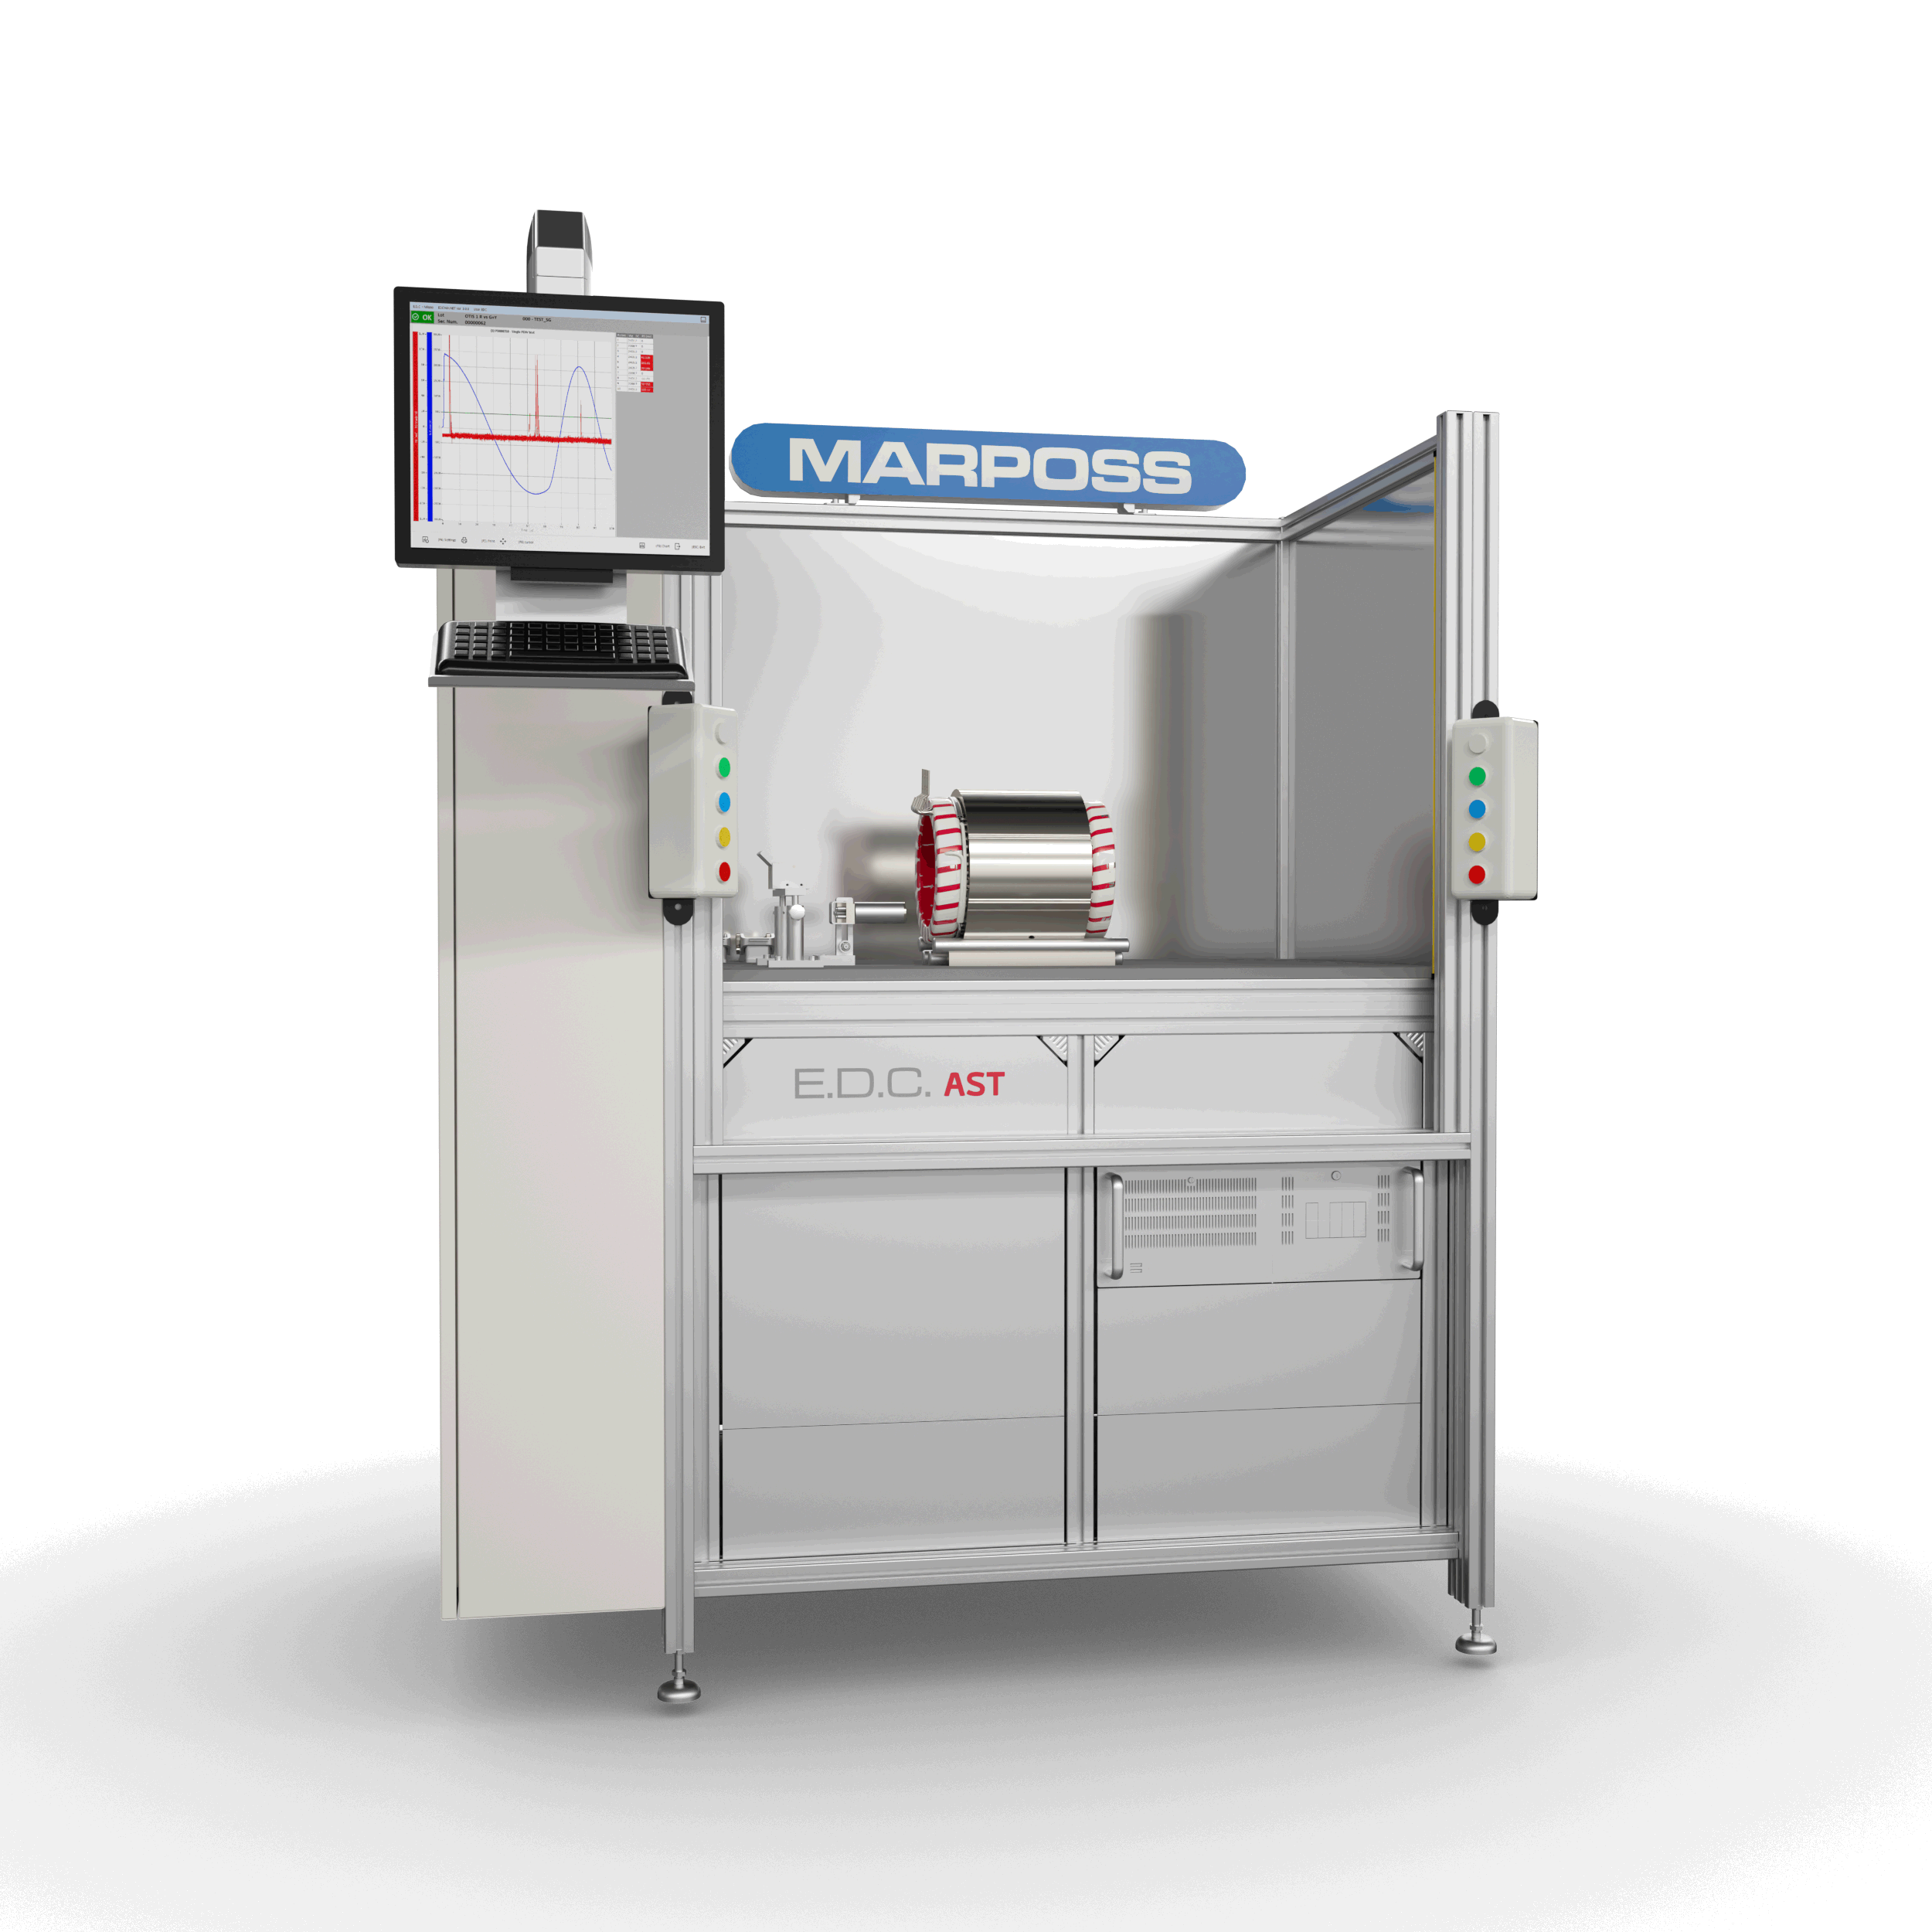
The Marposs e.d.c. AST320/W system for electric motor testing for production.
About Marposs
MARPOSS, founded in 1952, provides shop-floor solutions for measurement, inspection and testing in the production environment. Marposs’ solutions include gauging equipment of mechanical components, before, during and after the production process; monitoring solutions on machine tools; assembly and testing for many industry sectors; and automatic machines and inspection stations for production lines. MARPOSS is one of the main suppliers to the automotive industry providing solutions for both traditional and electric mobility but additionally operates in the aerospace, biomedical, hi-tech, white appliance, and glass containers industries. MARPOSS Group employs 3500 people around the world and is present in 34 countries with more than 80 sales offices.

CONTACT INFO:
Nancy Lesinski
Industry Scope (Agency)
248-709-3040
nlesinski@industry-scope.com
Silvia DiNicola
Marposs Corporation
silvia.dinicola@us.marposs.com
3300 Cross Creek Parkway, Auburn Hills, MI 48326
248-370-0404

