For Immediate Release
FABTECH 2023
Booth D41041

Marposs Features Brankamp Series of Press Monitoring Systems at FABTECH 2023

Chicago, Ill., Sept. 11, 2023 -- In booth #D41041 at FABTECH 2023, Marposs will display its family of Brankamp in-process real-time monitoring systems for stamping operations, suited for a wide range of press sizes from 40 – 2500 tons. The trend toward lightweight construction and increasing part complexity can result in higher deformation levels. These units help to immediately identify manufacturing faults and automatically compensate for variation in sheet thickness, material hardness, tool and machine temperature, speed, etc., during the manufacturing process. This enables manufacturers to optimize machine efficiency, improve part quality, and limit unplanned downtime and tooling costs.

How Brankamp Systems Work
Appropriate sensors (forces, ultra-emission, structure-borne sound, distance, temperature, binary) are positioned in either the machine or the dies to convert mechanical deformation into electrical signals that monitor tool and machine performances from applied forces. Using an adaptive pattern recognition process, the system learns the correct sensor signal profile for a given cycle. If the signals match the learned curve, the process is continuously observed, recording data for supervision of production, batch size, runtime behavior, and process trend aiming higher line efficiency. If the signal moves outside of the recognized envelope curve, the system informs the operator of the specific type, cause and location of the fault. If necessary, the system also triggers an emergency switch to stop the machine or sort out the defective part.
Brankamp Models
X3s: The X3s, with a high resolution 9” touch display, is used for process monitoring to enhance or optimize the process and improve part quality, providing a positive effect on overall equipment effectiveness.

X5: The Brankamp X5 is suited for machine and tool protection, process monitoring and process failure detection, as well as for optimizing process and part quality. It features a 12” touchscreen and eight channels for monitoring maximum forces, envelope curves and trend progressions. Additionally, six zoom channels offer detailed monitoring of specific, sensitive process areas such as distorted parts or a short feed.
X7: The X7 provides machine and tool protection, process monitoring and process failure detection, as well as optimization of process and part quality. It features a 15” touchscreen and up to 24 channels for monitoring maximum forces, envelope curves and trend progressions, as well as run times, setup times and downtime, or sensitive process areas such as distorted parts or a missed feed.

Brankamp solutions are compatible with high-speed, large-part transfer, notching, drawing, coining, multi-station and fineblanking presses, as well as automatic punching and stamping/bending machines.

Complete information about Marposs solutions for metal forming applications can be found at https://www.brankamp.com/eng/application/monitoring-solutions-for-stamping-machines, or by calling (248) 370-0404 or emailing marposs@us.marposs.com
-END-

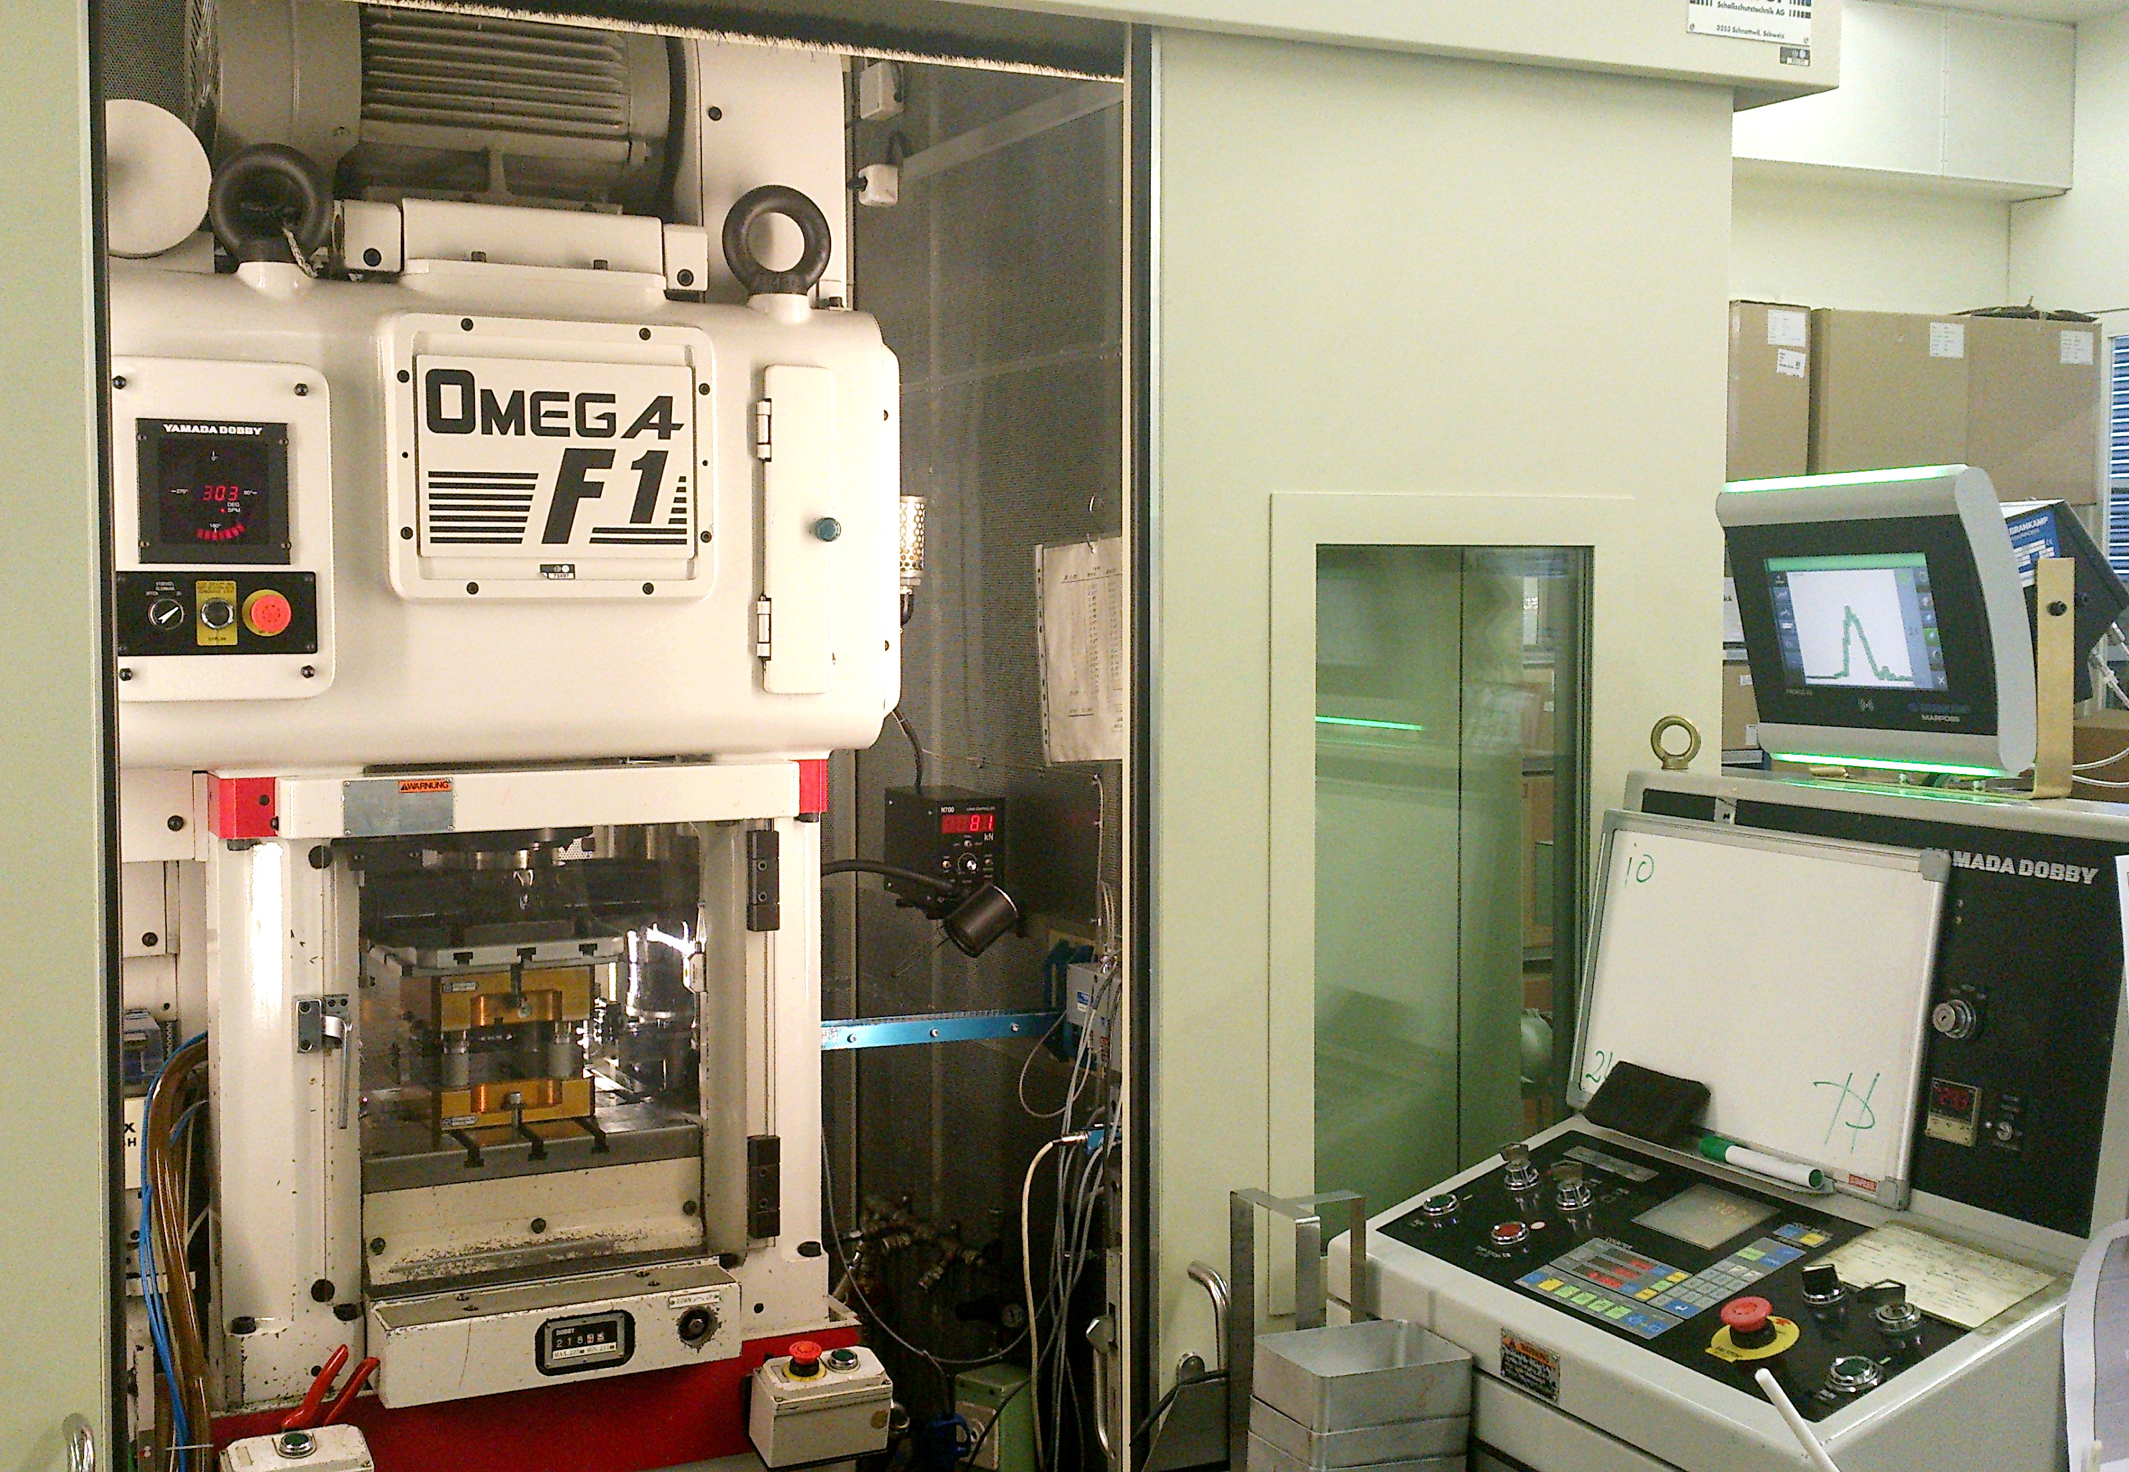
Marposs will feature its series of Brankamp machine monitoring devices for forming applications at FABTECH 2023.
About Marposs
Marpoaa, founded in 1952, provides shop-floor solutions for measurement, inspection and testing in the production environment. Marposs’ solutions include gauging equipment of mechanical components, before, during and after the production process; monitoring solutions on machine tools; assembly and testing for many industry sectors; and automatic machines and inspection stations for production lines. Marposs is one of the main suppliers to the automotive industry providing solutions for both traditional and electric mobility but additionally operates in the aerospace, biomedical, hi-tech, white appliance, and glass containers industries. Marposs Group employs 3500 people around the world and is present in 34 countries with more than 80 sales offices.

CONTACT INFO:
Nancy Lesinski
Industry Scope (Agency)
248-709-3040
nlesinski@industry-scope.com
Silvia DiNicola
Marposs Corporation
silvia.dinicola@us.marposs.com
3300 Cross Creek Parkway
Auburn Hills, MI 48326
248-370-0404

