For Immediate Release

BATTERY SHOW 2023
Booth #1016

Marposs Demonstrates Prismatic Battery Cells Electrical Testing System at The Battery Show 2023

Novi, Mich., Sept. 12, 2023 – Marposs, a global leader in measurement, inspection and test technologies, will demonstrate its Prismatic Battery Cell Testing System in booth #1016 at The Battery Show, North America, 2023, which incorporates the checking of dimensional characteristics, safety conditions, and electrical functional parameters into one system. This machine can be easily reconfigured to adapt to different cell sizes and is suitable for end of line control or verification and grading at the beginning of a module assembly line.
With the growing market for electric vehicles, manufacturers are under increasingly aggressive production schedules while ensuring quality and controlling costs. Marposs can help automakers manage their quality control, improving both process and product quality and decreasing waste.
Originally designed as a turntable system, the testing system can be loaded manually by an operator or through automation. Capable of handling up to 18 nesting stations, the arrangement is determined by the specific battery cell model and size. Marposs can also design the solution as an in-line station or end-of-line with conveyors.
Within a single system, the following inspection and tests are included:
Dimensional Check: The system begins by checking the cell’s main dimensional parameters using contact or chromatic confocal technology. A dedicated gripper, actuated by a servocontrolled two-axis manipulator, acquires the thickness of the cell in different contact points along the body of the cell itself. Number and position of the measuring points can be easily programmed according to customer’s requirements.
Electrical Check: The main station is dedicated to the electrical testing, where pogo-pin device closes the circuit between anode and cathode with a controlled force. The main functional electrical parameters, such as Open Circuit Voltage (OCV) and Alternating Current Internal Resistance (ACIR), are then measured. Other measurements such as Direct Current Internal Resistance (DCIR) or complete Electrochemical Impedance Spectroscopy (EIS) can be made at the customer's request.
Then, the integrity of the electrical insulation is checked (Hi-Pot test) by contacting all external surfaces with a conductive foam. At this stage, the system can also be designed to perform a Y-Capacitance test.
Leak Test: Finally, the sealing is verified in a leak testing station. Since the cell is already closed, direct tracing of electrolyte vapors in a vacuum chamber is used, a technology that Marposs has expressly developed and fine-tuned to ensure maximum testing speed in automatic applications designed to control mass production lines.
All the collected data are then stored in association with the serial number of the cell, read on the data matrix code.
For more information on solutions for electrical testing of battery cells, visit Electrical Testing of Prismatic Battery Cells, contact Marposs at 1-888-627-7677 or by e-mail to marposs@us.marposs.com.
###
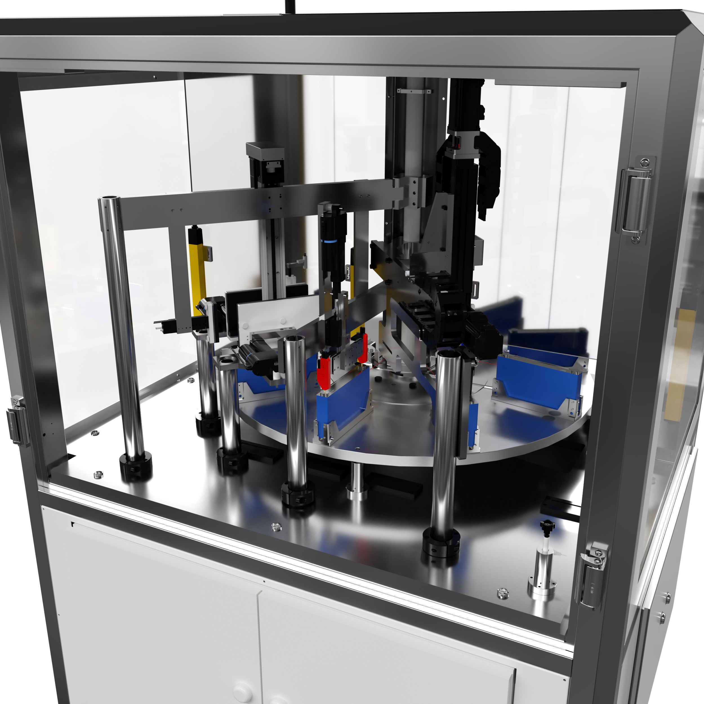
Marposs’ system for testing of Prismatic Battery Cells.

About Marposs
MARPOSS, founded in 1952, provides shop-floor solutions for measurement, inspection and testing in the production environment. Marposs’ solutions include gauging equipment of mechanical components, before, during and after the production process; monitoring solutions on machine tools; assembly and testing for many industry sectors; and automatic machines and inspection stations for production lines. MARPOSS is one of the main suppliers to the automotive industry providing solutions for both traditional and electric mobility but additionally operates in the aerospace, biomedical, hi-tech, white appliance, and glass containers industries. MARPOSS Group employs 3500 people around the world and is present in 34 countries with more than 80 sales offices.

CONTACT INFO:
Nancy Lesinski
Industry Scope (Agency)
248-709-3040
nlesinski@industry-scope.com
Silvia DiNicola
Marposs Corporation
silvia.dinicola@us.marposs.com
3300 Cross Creek Parkway
Auburn Hills, MI 48326
248-370-0404

