For Immediate Release

Star SU Carbide Hobs Support High-Performance Gear Manufacturing

Farmington Hills, Mich., August 28, 2026 — As manufacturers increase cutting speeds and seek greater machine utilization, tooling performance becomes increasingly important to maintaining productivity and gear quality. Longer production runs require cutting tools that hold tight tolerances, resist wear and perform consistently from the first part to the last.

Star SU offers carbide hobs designed for high-volume production of precision gears across the automotive, aerospace, energy and industrial markets.

Manufactured from premium carbide substrates, Star SU carbide hobs are engineered to maintain cutting accuracy under demanding machining conditions. Their wear resistance helps extend tool life while supporting consistent gear quality throughout longer production runs.

Each hob is designed for the specific application, taking into account gear geometry, workpiece material, machining parameters and production requirements. This application-focused approach helps manufacturers optimize cutting performance while achieving the accuracy and surface finish required for precision gear manufacturing.

Star SU also provides application engineering support to help customers select the appropriate tool geometry, carbide substrate and coating for their manufacturing process.

“Every gear manufacturing application presents a different set of challenges,” said Rick Yan, gear tool product manager. “Matching the hob to the application is just as important as the machine itself. By optimizing the tool for the cutting conditions, manufacturers can improve process stability, extend tool life and maintain consistent gear quality.”

Available in shell- and shank-style configurations, Star SU carbide hobs can be designed for wet or dry cutting and tailored to meet a wide range of gear manufacturing requirements.

The Star Cutter Family of Companies
Headquartered in Farmington Hills, MI, and originally founded in 1927, the Star Cutter Company is a global leader in the cutting tool industry with more than 700 employees working in 15 manufacturing facilities. Each facility specializes in producing a specific type of product or service: carbide blanks and preforms, solid carbide cutting tools, gundrills, PCD tooling, gear cutting tools, and 5-axis CNC tools and cutter grinding machines.

For more information, visit: www.starsu.com

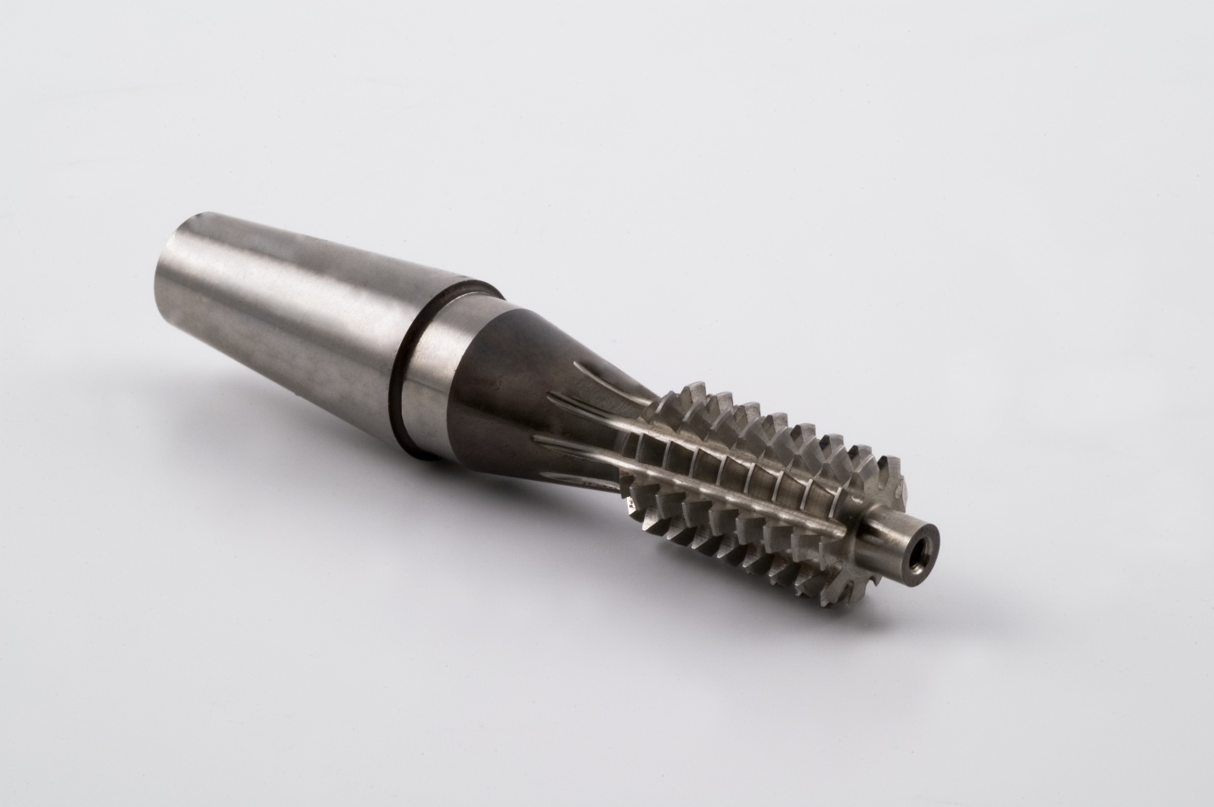
Figure 1: Star SU solid carbide hobs are available in shell and shank designs for dry or wet cutting applications, with multiple drive configurations and carbide grades to support a wide range of gear manufacturing requirements.

END

