For Immediate Release

Star SU Chamfer Hob Simplifies Precision Gear Chamfering

Farmington Hills, Mich., August 28, 2026 — Star SU offers its Chamfer Hob for producing high-precision gear chamfers in a single operation, eliminating secondary finishing and supporting more efficient gear production.

Chamfering shapes the edge where the tooth meets the gear face and plays an important role in gear performance, durability and safety. An improperly formed chamfer can leave gears more susceptible to breakage under heavy loads and high speeds. Remaining burrs can damage mating gears and bearings, while sharp edges can create handling hazards for operators.

Unlike conventional chamfering methods that may require additional processing, the Star SU Chamfer Hob produces a clean, burr-free edge with consistent geometry from part to part.

Designed for high-volume production, the tool can be resharpened multiple times to extend service life and reduce tooling costs. It also supports a wide range of gear geometries, including complex tooth profiles and applications with limited tool access.

Each Chamfer Hob is engineered for the specific gear geometry using Star SU application expertise and advanced 3D kinematic simulation. The simulation helps determine the appropriate tool design for challenging applications, including shaft gears with shoulder interference, ring gears with fixture interference and gears with inclined lateral surfaces.

“Chamfering has a direct impact on gear performance, durability and overall manufacturing quality,” said Rick Yan, gear tool product manager. “By designing each tool around the customer’s gear geometry, we can produce consistent chamfers while simplifying the manufacturing process.”

Star SU application engineers work with manufacturers to evaluate gear geometry, potential interference and production requirements, providing a Chamfer Hob designed for the specific application.

The Star Cutter Family of Companies
Headquartered in Farmington Hills, MI, and originally founded in 1927, the Star Cutter Company is a global leader in the cutting tool industry with more than 700 employees working in 15 manufacturing facilities. Each facility specializes in producing a specific type of product or service: carbide blanks and preforms, solid carbide cutting tools, gundrills, PCD tooling, gear cutting tools, and 5-axis CNC tools and cutter grinding machines.

For more information, visit: www.starsu.com

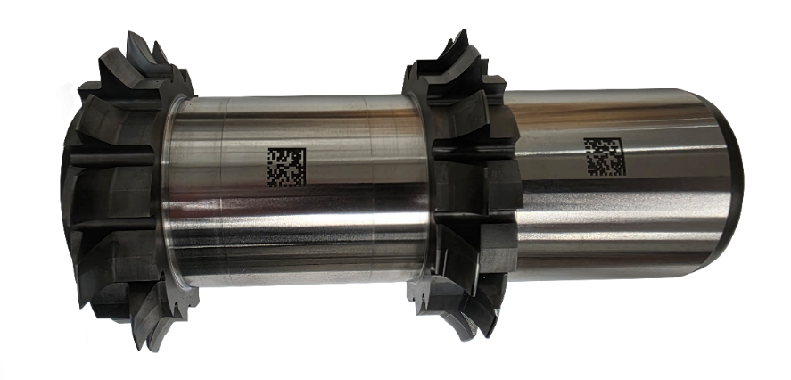
Figure 1: Star SU Chamfer Hobs produce clean, burr-free chamfers in a single operation and can be resharpened multiple times to support high-volume gear production.

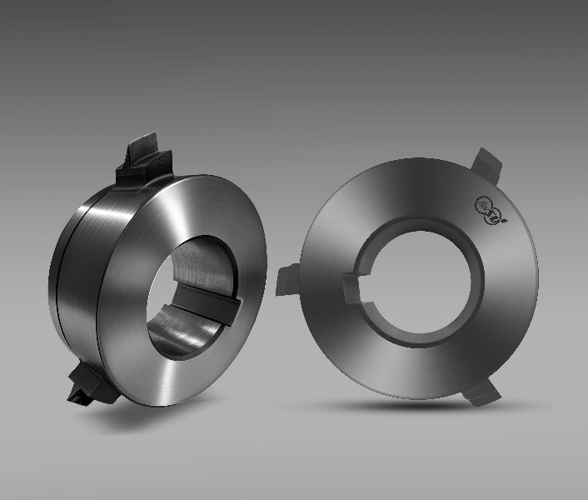
Figure 2: Each Star SU Chamfer Hob is engineered for the specific gear geometry using advanced 3D kinematic simulation to address complex profiles and tool-access limitations.

END

