For Immediate Release

Star Cutter Expands FLX Grinding Machine Platform with Quick Change Configuration

Farmington Hills, Mich., August 28, 2026 — As carbide costs continue to climb, manufacturers are placing greater emphasis on extending tool life through resharpening. At the same time, many shops need a flexible grinding platform that supports manual production while providing a path to automation as volumes grow.

Star Cutter has introduced the FLX Quick Change, a compact five-axis tool and cutter grinder designed for tool resharpening, prototype work and hand-loaded production.

“Not every shop needs a fully automated grinding system,” said Aaron Remsing Jr., sales and product manager. “Many need a machine that delivers precision and flexibility today, with the ability to add automation as production demands change.”

A quick-change two-wheel system allows operators to change wheel packs in minutes, reducing setup time when moving between tool geometries or grinding operations. The machine’s compact footprint makes it well suited for shops where floor space is limited, while its thermally stable design helps maintain grinding accuracy as shop conditions change throughout the day.

The FLX also features a direct-drive rotary axis that provides precise positioning and smooth axis motion for consistent grinding performance across a wide range of cutting tool applications.

Automated loading and unloading can be added as production volumes increase, allowing manufacturers to expand the machine’s capabilities without investing in a new grinding platform.

The FLX Quick Change is equipped with Star Cutter’s redesigned NCI/HMI software, now standard across the company’s five-axis grinding platforms. The updated interface includes data logging and collection tools that provide greater visibility into machine performance, production trends and operating efficiency.

The Star Cutter Family of Companies
Headquartered in Farmington Hills, MI, and originally founded in 1927, the Star Cutter Company is a global leader in the cutting tool industry with more than 700 employees working in 15 manufacturing facilities. Each facility specializes in producing a specific type of product or service: carbide blanks and preforms, solid carbide cutting tools, gundrills, PCD tooling, gear cutting tools, and 5-axis CNC tools and cutter grinding machines.

For more information, visit: www.starcutter.com

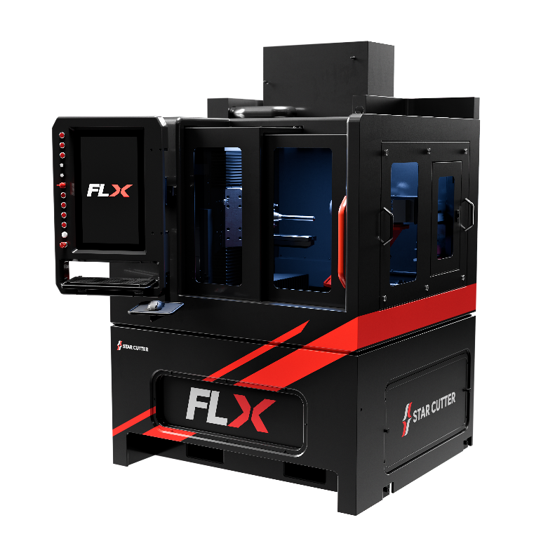
Figure 1: The Star Cutter FLX Quick Change is a compact five-axis tool and cutter grinder featuring a quick-change two-wheel system and the ability to add automated loading and unloading as production needs evolve.

END

