For Immediate Release

Star Cutter Expands Grinding Automation Capabilities

Farmington Hills, Mich., August 28, 2026 — Star Cutter has introduced its new Flexible Automation Cell, a demonstration platform that brings together automation hardware, software and secondary processes within a connected grinding workflow. The cell shows how these technologies can be integrated across many of the company’s CNC grinding platforms to address different production requirements.

The process begins with an RFID reader that identifies and tracks each part as it moves through the cell. A Cognex vision system verifies and corrects part orientation before processing. Automated part flipping and an integrated deburring station allow multiple operations to be completed within a single workflow.

The cell can also incorporate laser engraving and debrazing, giving manufacturers the flexibility to add secondary processes based on their specific applications.

“The most effective automation solutions are built around the manufacturing process, not the other way around,” said Aaron Remsing Jr., sales and product manager. “The Flexible Automation Cell shows how Star Cutter integrates different technologies to support each customer’s production goals.”

Star Cutter also offers software solutions for broach grinding, dressing and automation simulation. The simulation software allows manufacturers to develop, validate and optimize automated workflows before machining begins.

By combining part identification, material handling, software and secondary operations, the Flexible Automation Cell reflects Star Cutter’s approach to developing practical automation solutions for grinding applications.

The Star Cutter Family of Companies
Headquartered in Farmington Hills, MI, and originally founded in 1927, the Star Cutter Company is a global leader in the cutting tool industry with more than 700 employees working in 15 manufacturing facilities. Each facility specializes in producing a specific type of product or service: carbide blanks and preforms, solid carbide cutting tools, gundrills, PCD tooling, gear cutting tools, and 5-axis CNC tools and cutter grinding machines.

For more information, visit: www.starcutter.com

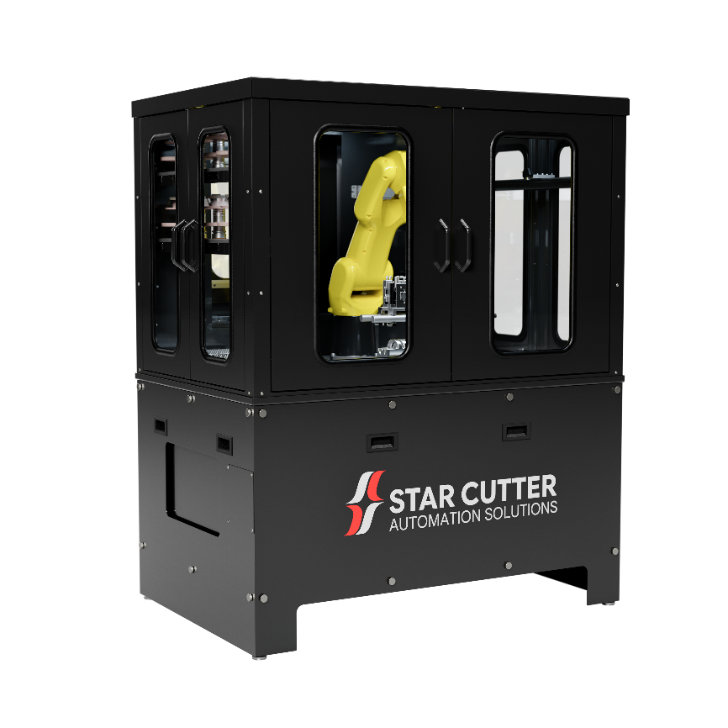
Figure 1: The Flexible Automation Cell from Star Cutter integrates part tracking, vision inspection, automated handling and secondary operations within a connected grinding workflow.

END

