For Immediate Release

Star Cutter Expands Automation Capabilities of the T93XM-A Centerless Grinder

Farmington Hills, Mich., August 28, 2026 — Star Cutter has introduced the latest version of its Tru Tech T93XM-A High Precision Centerless Profile Grinder, featuring expanded robotic automation and redesigned software to support longer unattended production runs and simplify operation.

Designed for manufacturers producing high-precision cylindrical components, the T93XM-A performs profile, plunge, peel, in-feed and thru-feed grinding. This versatility allows manufacturers to process a wide range of part geometries and perform multiple grinding operations on a single machine platform.

The latest T93XM-A incorporates a six-axis FANUC 200iD robot and a five-pallet configuration, increasing capacity by 67 percent to support longer periods of unattended production.

Star Cutter has also redesigned the automation software with an intuitive operator interface and integrated 3D simulation. Instead of programming individual pallet layouts, operators select the desired pallet array, load the parts and begin production. This streamlined workflow reduces setup requirements and makes automation more accessible across different production environments.

A redesigned gripper assembly enables rough and finish grinding to be completed within the same automated cycle. Keeping the part within one continuous process reduces handling between operations and supports more efficient production.

“Manufacturers are looking for automation that integrates easily into their operations without adding unnecessary complexity,” said Aaron Remsing Jr., sales and product manager. “The updated T93XM-A is easier to set up and operate while providing the flexibility to handle a wider range of centerless grinding applications.”

The Star Cutter Family of Companies
Headquartered in Farmington Hills, MI, and originally founded in 1927, the Star Cutter Company is a global leader in the cutting tool industry with more than 700 employees working in 15 manufacturing facilities. Each facility specializes in producing a specific type of product or service: carbide blanks and preforms, solid carbide cutting tools, gundrills, PCD tooling, gear cutting tools, and 5-axis CNC tools and cutter grinding machines.

For more information, visit: www.starcutter.com

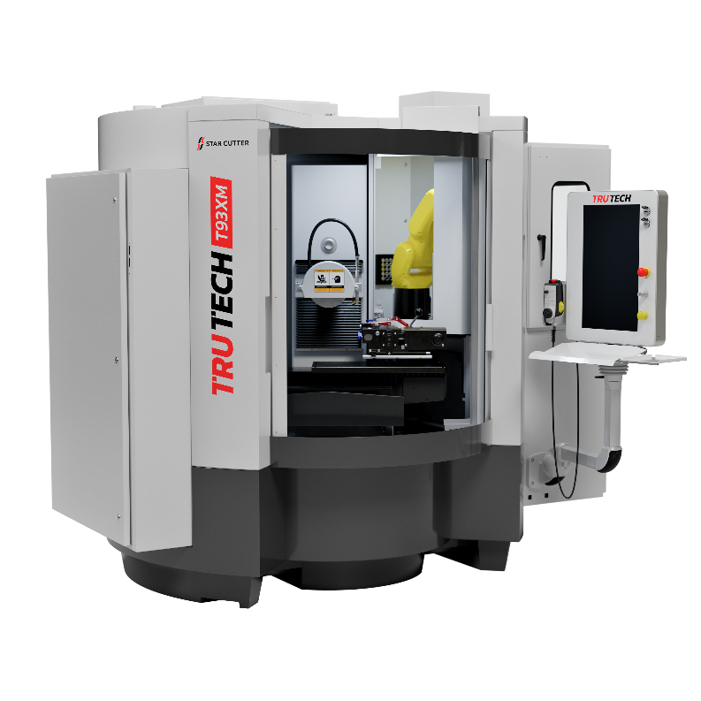
Figure 1: The Tru Tech T93XM-A from Star Cutter combines high-precision centerless profile grinding with six-axis robotic automation and a five-pallet configuration to support longer unattended production runs.

END

