BLM GROUP USA to Showcase Automation Ready Tube and Sheet Metal Solutions at FABTECH 2026

Novi, Mich., Sept 15, 2026 – BLM GROUP USA will demonstrate a broad range of machine technologies, automation and software for tube and sheet metal processing at FABTECH 2026, October 21-23 in Las Vegas. Visitors to Booth C1208 will see live demonstrations spanning tube bending, tube laser cutting, sheet laser cutting, press brake bending and 5-axis laser processing.
The lineup reflects the breadth of the BLM GROUP product portfolio, with technologies that can operate as standalone systems or integrate with automation, material handling and software as production requirements evolve. Systems on display range from all-electric tube benders to laser systems for processing flat sheet, tube and complex three-dimensional components.
All-Electric Tube Bending for Different Production Requirements
BLM GROUP will demonstrate two all-electric tube bending systems, the E-TURN 40 and ELECT 102, highlighting different approaches to producing complex tubular components.
The E-TURN 40 combines right- and left-hand bending in the same cycle, allowing manufacturers to produce complex geometries that can be difficult to achieve with conventional bending processes. Built on all-electric technology, setup and bending parameters are stored with the part program to support fast production changes and consistent repeatability. The E-TURN 40 accommodates tube diameters up to 1.5 in. (40 mm).
For larger tube applications, the ELECT 102 processes tube up to 4 in. (102 mm) in diameter. The all-electric system can be configured for right- or left-hand bending and is designed for applications requiring the precision and control of electric bending technology on larger, more robust tubular components.
Both systems use BLM GROUP VGPNext 3D programming software, which manages bending parameters and machine setup from part development through production, helping simplify programming and support repeatability across production runs.

Sheet Metal Cutting and Bending
For manufacturers working with flat sheet, BLM GROUP will demonstrate the LS7 Sheet Laser alongside the ProBend E-series Press Brake, giving FABTECH visitors an opportunity to see technologies supporting both cutting and bending operations.
The LS7 combines up to 20 kW of laser power with acceleration up to 2g and a fully electric pallet changer that completes a pallet change in nine seconds. Active Tools technologies automatically manage cutting parameters across different materials and thicknesses, while available loading, unloading and storage automation allow the LS7 to be integrated into automated sheet processing workflows. Recent updates improve machine accessibility with a larger front door, additional side access and a new ergonomic, adjustable operator control panel.
The ProBend all-electric press brake uses a patented direct-drive torque motor to provide precise control throughout the bending process. Available with a 6-axis backgauge for complex part geometries and tapered bends, the ProBend also offers CNC-controlled sheet followers that synchronize with the press brake to support workpieces up to 330 lb. (150 kg). For automated bending, the ProBend can be integrated with the HBS II Robotic Bending Cell, which automates sheet loading, bending and palletizing. Offline programming coordinates the press brake and robot within a single production cell.
Tube Laser Cutting in a Compact Platform
The LT6 Tube Laser brings full 3D laser cutting capabilities to a compact tube processing system. The machine processes tube from 0.5 to 6 in. (12 to 152 mm) in diameter and material weighing up to 12 lb./ft. (18 kg/m).
A fully automatic bundle loader supports high-volume production, while extended loading chains provide flexibility for special and heavier profiles. Three programmable unloading positions and automatic scrap separation manage part unloading and scrap handling after cutting. BLM GROUP Active Tools automatically adapt cutting parameters, compensate for tube deformation and detect weld seam position during processing. An optional automated rivet insertion unit installs M4 to M12 threaded inserts as part of the tube processing cycle. The LT6 is programmed using ArTube CAD/CAM software, which allows operators to import, create or modify 3D tubular parts and assemblies and generate the corresponding machine programs.
5-Axis Laser Processing for Complex 3D Parts
Completing the laser technology lineup will be the LT-FREE 5-axis laser cutting system for processing complex three-dimensional components.
The LT-FREE combines 5-axis laser cutting with automated robotic part handling to cut formed, hydroformed, stamped, pre-welded and other three-dimensional components. The system provides full access around the workpiece, allowing manufacturers to trim profiles, cut holes and create complex contours on parts with varying geometries and thicknesses. ArGo programming software manages the cutting path and robot movement within a single programming environment.
With multiple configurations available, the LT-FREE can support applications ranging from prototypes and frequently changing production requirements to higher-volume manufacturing.
Together, the technologies being demonstrated at FABTECH illustrate how BLM GROUP supports manufacturers as production requirements evolve. Visitors can evaluate individual machines while exploring how automation, material handling and software can connect cutting and bending technologies within a broader production workflow.
# # #

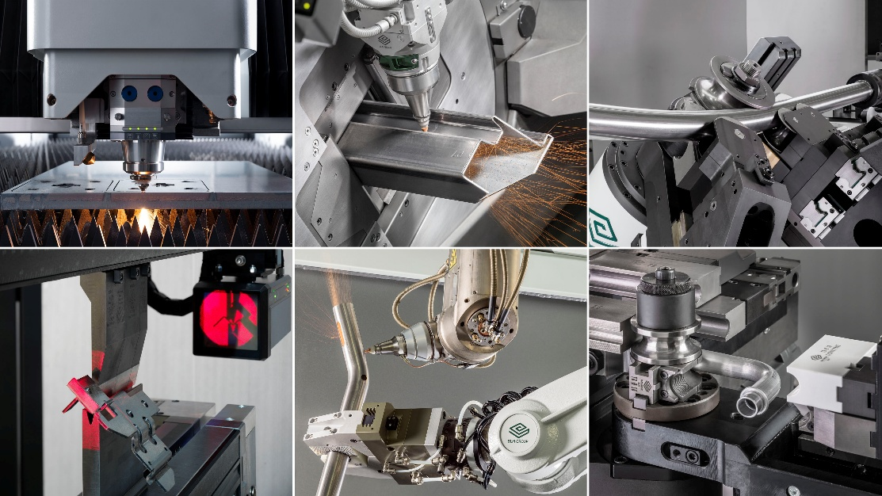

About BLM GROUP
BLM GROUP is a global leader in tube and sheet metal machine solutions. Its product portfolio includes tube lasers, 5-axis lasers, sheet lasers, press brakes, tube benders, wire benders, end-formers and cold saws. The company has more than 65 years of experience and thousands of applications globally and serves customers in the United States and Canada from its North American headquarters, located in Novi, Michigan. Visit BLMGROUP.com, call 248-560-0080 or email sales@blmgroupusa.com for machine information.

Editorial Contact – Agency
Dawn Frasa
Industry Scope
248-872-7583
dfrasa@industry-scope.com

