BLM GROUP Debuts New Approach to
Mandrel Bending from Coil

Novi, Mich., Sept 15, 2026 – BLM GROUP USA will introduce the PRO-RUNNER 28 to the North American market at FABTECH 2026 in Las Vegas, Booth C1208. Designed to produce complex tubular components from coil, the all-electric tube bending system features patented mandrel bending technology and combines multiple operations in a continuous workflow.

The PRO-RUNNER 28 processes tubes up to 28mm in diameter and integrates straightening, calibration, end-forming, bending, drilling, cutting and automatic unloading. A magnetically suspended mandrel positioned inside the tube enables mandrel bending directly from coil, supporting tight bend radii and thin-wall applications while minimizing ovalization.

“PRO-RUNNER 28 gives manufacturers a different way to approach high-volume tube production,” said Matt Irwin, product manager, tube and wire forming products at BLM GROUP USA. “When you're producing tubular components with complex geometries, every additional handling step adds time to the process and creates opportunities for error. Starting from coil and completing multiple operations on one system simplifies how those parts move through production while supporting more consistent part quality.”

Traditional coil-fed bending systems can be limited when an application requires internal mandrel support. The patented mandrel technology of the PRO-RUNNER 28 addresses this challenge, enabling high-quality bends with small centerline radii and thin-wall tubing while maintaining continuous coil-fed production. Because material is supplied from coil rather than pre-cut lengths, manufacturers can produce long tubular components without the length restrictions associated with conventional tube-fed processes. Vertical, horizontal and jumbo coil feeder options allow manufacturers to configure the system based on production volume and available floor space.

The PRO-RUNNER 28 supports mandrel and non-mandrel bending using rotary draw or compression bending, with fixed and variable multi-radius capabilities that can be combined on the same part. Right- and left-hand bending further expands its ability to produce complex 3D geometries and serpentine shapes.

Beyond bending, the PRO-RUNNER 28 can integrate additional operations into the same automated production sequence. An end-forming module accommodates a range of forming operations, while an optional spindle motor enables drilling after bending, including within curved sections, without affecting tube circularity. A Collar Drill device can also be integrated to produce collared holes that simplify subsequent manufacturing or assembly operations. Tooling changeovers are quick, with simplified setup and assembly between jobs.

Programming is performed through BLM GROUP VGPNext software, with 3D simulation allowing users to evaluate the bending sequence before production begins.

The PRO-RUNNER 28 is well suited for small- and medium-diameter tubular components used in automotive, HVAC, industrial vehicle, appliance, furniture and contract manufacturing applications. By bringing coil feeding, bending and additional processing operations together on one system, manufacturers can reduce the need to move parts between separate machines and operations.

# # #

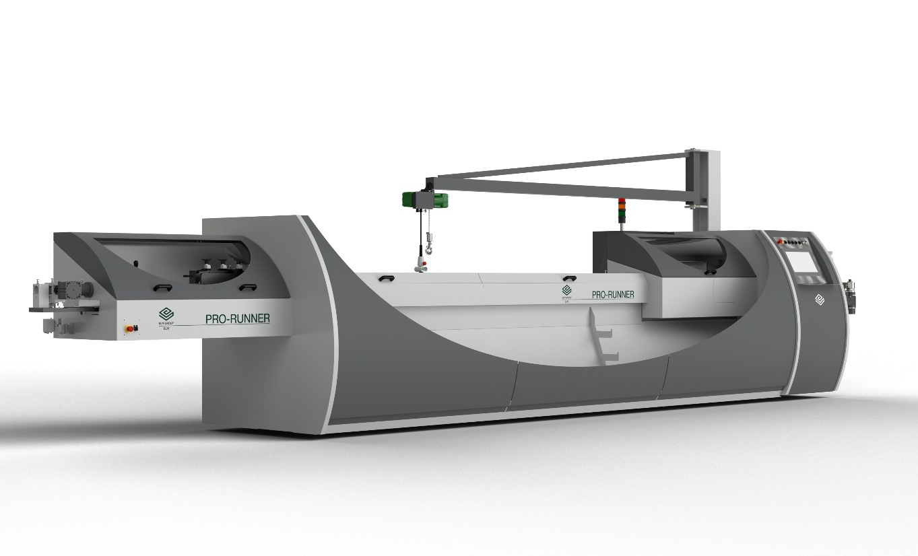

About BLM GROUP
BLM GROUP is a global leader in tube and sheet metal machine solutions. Its product portfolio includes tube lasers, 5-axis lasers, sheet lasers, press brakes, tube benders, wire benders, end-formers and cold saws. The company has more than 65 years of experience and thousands of applications globally and serves customers in the United States and Canada from its North American headquarters, located in Novi, Michigan. Visit BLMGROUP.com, call 248-560-0080 or email sales@blmgroupusa.com for machine information.

Editorial Contact – Agency
Dawn Frasa
Industry Scope
248-872-7583
dfrasa@industry-scope.com

