BLM GROUP USA Opens New Training Center
as Centerpiece of its North American Headquarters Expansion

Novi, Mich., Sept. 15, 2026 – BLM GROUP USA, announces the opening of its expanded Training Center, a key component of a broader expansion at the the company’s North American headquarters in Novi, Michigan. The project adds 65,000 square feet of new space, nearly doubling the size of the campus to more than 140,000 square feet.
The expansion reflects the company’s commitment to customer success, giving customers and employees alike the space, equipment and hands-on support to build lasting expertise on their machines and with software and programming.
The Training Center includes a new 17,000-square-foot machine training bay and an additional 38,000 square feet of classroom, administrative and service space, including a technical lab for BLM GROUP employees.
“In today’s manufacturing environment, operator training is vital,” said Jim Crocker, manager of training, development and laser application at BLM GROUP USA. “The expanded Training Center lets us go deeper with more hands-on time on the machines along with innovative classroom space where our customers can build real skills in software and programming. And all of that training really is just the starting point of the support we provide customers throughout the life of their equipment.”
With nearly double the space previously dedicated to training, the Training Center provides greater flexibility to accommodate customer training and employee technical development.
The machine bay includes an LT6 tube laser, two LT7 tube lasers and an LT8 tube laser, along with two LS7 flat sheet lasers. The additional space and equipment significantly increase training capacity, allowing BLM GROUP to offer up to eight machine training classes per week.
The software training space also has grown substantially, from two rooms with capacity for 24 people to four training rooms with capacity for 40 people at a time. The new classrooms feature stadium-style seating for better sightlines and an 86-inch interactive touch-screen panel that the trainers can use in a variety of ways including projecting an individual student’s screen for the full class to see and understand how to work through issues as well as supporting hands-on group troubleshooting and learning.
The hands-on technical lab for BLM GROUP employees features a dedicated tube laser used for training, troubleshooting and diagnostics so technicians can gain advanced skills to apply in the field.
The Training Center is now open, with the remaining expansion expected to be completed by early 2027.
# # #

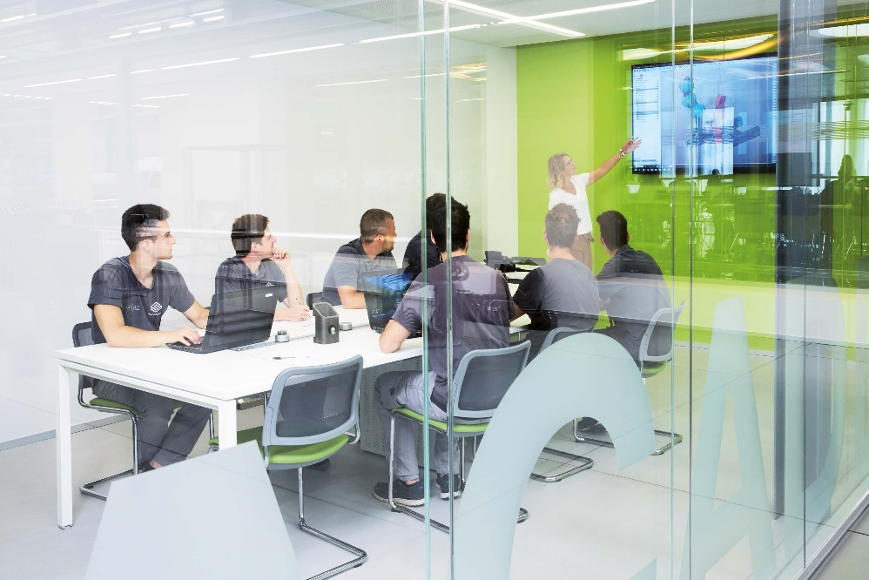

About BLM GROUP
BLM GROUP is a global leader in tube and sheet metal machine solutions. Its product portfolio includes tube lasers, 5-axis lasers, sheet lasers, press brakes, tube benders, wire benders, end-formers and cold saws. The company has more than 65 years of experience and thousands of applications globally and serves customers in the United States and Canada from its North American headquarters, located in Novi, Michigan. Visit BLMGROUP.com, call 248-560-0080 or email sales@blmgroupusa.com for machine information.

Editorial Contact – Agency
Dawn Frasa
Industry Scope
248-872-7583
dfrasa@industry-scope.com

